Personal, Social and Emotional Development |  | Autumn: | Spring: | Summer: | Key Vocabulary:
Self-Regulation  RHE  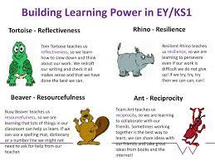 | Knowledge and skills: | I am building my self-regulation supported by routines and visual timetables.  I Know that all feelings are valid.  I go to a safe place or area to work through my emotions | I know what makes a good listener/friend/learner  I can follow the class rules | I can respond to a range of music and stories linked  to feelings  I can introduce myself to new friends. | Feeling  Happy  Sad  Good  Bad  Sleepy  Angry  Upset  Cry  Tired  Scared  Hurt  Behaviour
 | How it is taught: | Transition and settling in of new children.  Building positive relationships with staff and peers.  Calm me time –mindfulness  Visual timetables  Colour Monster Story.
Managing Self  RHE  D&T  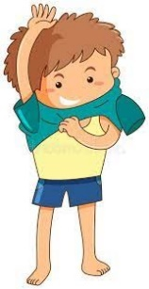 | Knowledge and skills: | I can make sad faces  and happy faces in the mirror  I can describe what my body can do  I can manage my own personal belongings  I am beginning to recognise danger and risks.  I recognise my personal  needs e.g., taking a drink when thirsty, taking  jumper off when hot, putting a coat on when  raining.  I can dress and undress for the toilet.  I can feed myself: using a cup and spoon. | I can talk positively about  myself.  I can suggest similarities and differences within my peer group  I recognise risk and danger  independently.  I can put on waterproof clothes and wellington  boots hats and gloves for the appropriate weather  outside.  I can use cutlery appropriately knife, fork and spoon. | I am developing my independence in toileting and eating.  I am aware and celebrate cultural differences  I can manage my own risks.  I collect my own belongings when leaving  nursery.  I am beginning to use cooking utensils independently | Happy  Brave  Strong  Proud  Special
 | How it is taught: | Class/school rules.  Healthy eating/exercise.  Oral health.  Similar but unique/ people have different skin colour.  Celebration books supporting separation  EYFS Picture News  Celebration assemblies  Show and tell
Building Relationships  RHE  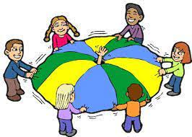 | Knowledge and skills: | I will notice photographs of familiar adults, children and teachers in my setting  I can join small circle games / group times.  I can copy the adults modelling positive behaviour and build  trustful relationships. | I am aware of the emotions of others.  I can show respect and empathy to my peers and other living things  I can link emotions too particular situations based on my experiences | I can use Smile puppets to problem solve strategies relating to relationships and personal feelings.  I can participate in group games such as parachute  and rug games with peers unsupported.  I can explain how and why we care for living things. | Friend  Family  Mum  Dad  Listening  Talking  Kindness  Brother  Sister
 | How it is taught: | Team’s meetings: building relationships with families.  Facebook group dialogue between nursery and home.  Adults model respectful dialogue” how can we support friends who are sad?"  - Dialogic stories  - Circle time  - Positive play  - Planned opportunities for collaborative learning.
Physical Development: |  | Autumn: | Spring: | Summer: | Key vocabulary:
Gross Motor Skills  P.E  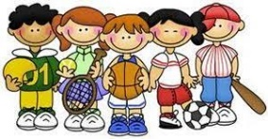 | Knowledge and skills: | I can copy action rhymes-finger / action songs and  physical action rhymes that link to dancing  e.g., heads, shoulders, knees, and toes.  I can negotiate space in small group spaces.  I can carry out balancing tasks outside- transporting,  pushing, pulling.  I can throw a large ball/ bean bag into the air or a large, opened container | I can move in response to music.  I can copy ways of moving- twisting, curling.  I can move on different levels and surfaces using parts of my body.  I can ride on a push along toy or a balance bike  I can throw and catch large balls, scarves,  and hoops. | I can follow a dance routine with extended  sequences  I can join in throwing and catching, games with small  equipment.  I can balance and push myself along on bikes and  scooters.  I can move across equipment e.g., without our knees touching or us without taking our  hands away. | run  jump  climb  throw  catch  balance  hop  squat  pedal  gallop
 | How it is taught: | p.e sessions in the hall  Continuous provision opportunities.  Adult lead sessions planned in during CIL.  Cosmic kids yoga
Fine Motor Skills  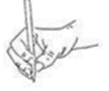 | Knowledge and skills: | I can mark make with lines and marks.  I can hold scissors correctly  I can move objects varying in size from one container to another using one hand. | I can mark make with emerging control creating  lines and circular marks.  I can use scissors to snip paper  I can thread large beads onto a string | I can draw differentiated shape representations  to share ideas with adults.  I can use scissors effectively to cut straight lines  I can thread small beads onto a string | Build  Draw  cut  stack  build  colour  scribble  copy  pinch  thread  peel  twist  manipulate
 | How it is taught: | Planned activities during continuous provision  Adult lead planned activities.  Dough disco
Communication and  Language development: |  | Autumn: | Spring: | Summer: | Key vocabulary:
Listening,  Attention and  Understanding  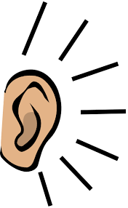 | Knowledge and skills: | I can listen when in a  Conversation with one other.  I can listen to a story with pictures and props.  I can join in with familiar  phrases in a story.  I can follow a simple 1 step  instruction.  I join in with at least six simple action rhymes  I use gestures/signs to respond to the  communication of others.  I understand verbal language relating to routines e.g., sit in the group, hang up  your coat.  I understand simple sentences e.g., Sit with  the group, go outside | I can listen in a small group.  I can introduce a  storyline into my play.  I can maintain attention and build concentration.  I can listen and do for short spans of time.  I can name some everyday sounds  I can join in songs and rhymes  I can share knowledge and ideas with my peers.  I can repeat rhythms, beats (syllables)  I understand sequential instructions relating to routines, e.g. you are  working outside with Victoria, over by  the compost bin.  I am beginning to respond to who, what, and where,  in simple questions. | I can follow stories  without pictures or props.  I can question why things  happen.  I can give an explanation  as to why things happen.  I understand how and why  questions.  I can respond within peer groups to questions  posed  I can identify rhythm and rhymes, sharing and  extending them.  I understand more complex sequential  instructions, eg you are working with the number  rods in the lab first, then next, you are working  outside (making use of time related language). | Listen  Look  Wait  Quiet  Stop  Ready  Same  Different  Name  Hear  Loud  Soft  First  Next  Now  Then  Because  If  Who  What  Why  Where  When  How
Speaking  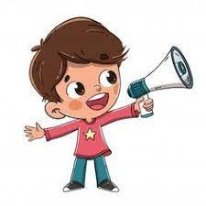 | Knowledge and skills: | I can use single words and simple sentences to  describe what I can see, here, etc  I can ask for things to meet my needs, e.g.  apple please.  I use gesture signs and single words to  pretend during play  I know and talk about people of importance to me e.g family and  friends.  I can retell simple past events/experiences in order. | I explain what is  happening and what  might happen next.  I am asking simple questions, e.g. what's  that? What are you doing? Who is that?  I can use simple sentences to pretend during play. | I understand and build  vocabulary that reflects  my own experiences.  I am using more complex sentence is to pretend and to engage in imaginative dialogue.  I am asking more complex questions, including what and how.  I am recalling past experiences and engaging others in shared experiences  I can use dialogue with peers to exchange views and make sense of ideas | Nouns:  People: mom, dad, baby, brother, sister, grandma, grandpa  Animals: dog, cat, bird, fish, horse, cow  Objects: car, ball, chair, table, cup, spoon, toy, book  Food: apple, banana, milk, juice, cookie  Parts of the body: head, arm, leg, foot, hand  Places: home, school, park, store  Verbs:  Action words: run, jump, walk, play, eat, drink, sleep, draw, build  Social words: say, ask, give, want, like  Adjectives:  Describing size: big, small, tall, short, long  Describing feelings: happy, sad, angry, tired  Describing colours: red, blue, green, yellow  Describing quantity: more, less, some, all  Other useful words:  Pronouns: I, you, he/she, my, your, his/her  Prepositions: on, in, under, over, behind, next to  Connectives: and, because, if  Question words: what, where, why, who, when  Social phrases: please, thank you, you're welcome, excuse me, sorry  Numbers: one, two, three..  Days of the week: Monday, Tuesday…  Months of the year: January, February…
 | How it is taught: | C&L is interwoven into all elements of the EYFS in each term  -Rich language environment  -Listening and engaging in story time and non-fiction texts  - Answering and asking W’s questions in whole class reading and PSED  - Learning rhymes, poems and stories  - Circle time  - Explicit teaching of new vocabulary in whole class reading and during adult lead activities.  Concept cat programme.  Neli and Talk Boost programme.
Understanding the World |  | Autumn: | Spring: | Summer: | Key vocabulary:
Past and Present  History  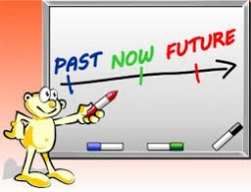 | Knowledge and skills: | I can show an interest in the  lives of people who I am  familiar with.  I can talk about significant events in my own life. | I understand some talk about immediate past, ie before, soon and later.  I understand that I have grown and changed since I was a baby.  I can say some of the ways I have changed.  I can say how old I am.  I understand that we grow from baby to child to adult.  I can use time related language such as , when I, before, now…  I can talk about some of the similarities and differences in relation to my friends and family. | I understand similarities  and differences between  my own family and other  families.  I remember and talk about  significant events in my  own experience.  I can talk about my time  at Nursery.  I understand I will be  starting school soon and can talk about the future in this context. | Old  New  Past  Present  Then  Now  long ago  today  grandma/Granny/Nan/Nanny  grandpa/grandad/pops  baby  family
 | How it is taught: | Adult lead activities and planned continuous provision.  Visits from visitor  Photographs from home
People, Culture and  Communities  R.E  Geography  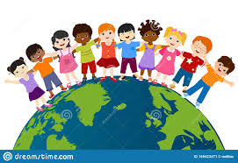 | Knowledge and skills: | I can talk about things I like and dislike.  I enjoy joining in with my family routines and traditions.  I can talk about things I see in Nursery and different areas of school.  I can ask questions about where things are. | I can talk about the place where I live and where I go to school.  I can talk about what I see in my surrounding areas.  I can ask questions about what I see.  I know some of the things that make me unique. | I can talk about my family customs and routines, and I understand these can be different to other peoples.  I can talk about my  favourite places.  I understand what makes  places special to people.  I can talk about starting  school and how that  makes me feel.  I can experience visiting  places beyond the school  grounds. | Family  Community  Home  Friend  Birthday  Holiday  Celebration  Different  Same  Belong  Special  Place  Doctor  teacher
 | How it is taught: | Cultural celebrations  Birthday celebrations  Visits and visitors  Forest school sessions
The Natural World  Science  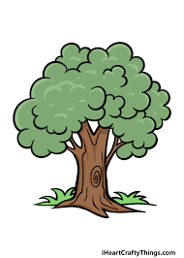 | Knowledge and skills: | I can use my senses as I explore and talk about natural materials.  I can talk about why things  happen and how things work.  I understand the weather  changes.  I can say what the weather is doing today.  I understand that the weather changes in Autumn and Winter.  I recognise the changing colour of the leaves.  I notice and talk about details in items from the environment. | I can use all my senses in  hands-on exploration  of natural materials.  I can talk about some of  the things I have  observed such as plants,  animals, natural and  found objects.  I enjoy playing with small  world reconstructions,  building on first-hand  experiences, e.g. visiting  farms, garages, train  tracks, walking by river  or lake.  I understand there are patterns and change in nature.  I understand things grow and change over time. | I can show care and concern for animals and people.  I can look after nature.  I can explore natural materials.  I understand the effect my behaviour can have on the environment.  I can show care and concern for the environment.  I enjoy joining in with  family customs and  routines. | Dog  Cat  Bird  Fish  plant  leaf  flower  stem  root  tree  sun  rain  sky  grow  change
 | How it is taught: | Forest school activities  Adult lead activities and planned continuous provision.
Expressive Arts and  Design |  | Autumn: | Spring: | Summer: | Key vocabulary:
Creating with  Materials  Art  DT  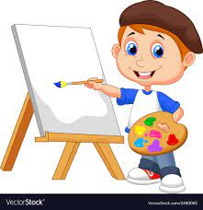 | Knowledge and skills: | I know different tools can be used to create different  outcomes.  I can use colour and talk about what I see.  I can explore construction kits.  I can experiment with different tools to create (paintbrush, glue,  roller, paint)  I can 3D materials in my work e.g. decorating a clay pot… | I can use a variety of  joining materials such as  Sellotape, glue, hole  punch, treasury tags,  stapler.  I can use various  construction materials to  build and balance.  I can practice using a range of tools and techniques.  I can construct using found and natural materials.  I notice detailed features of objects in my environment.  I can make snips in paper  using scissors.  I can use 2D and 3D materials in my work eg. decorating a clay pot… | I can create simple  representations of events,  people and objects that  are important or familiar  to me.  With support, I can use  cooking tools e.g. grater,  safety knife, whisks.  I can use forward snipping  Motion  I can choose and use  materials to create  something I have planned.  I can use tools safely.  I can use construction  kits to build for challenges.  I can create 3D models such as a clay pot | Colours:  Red, blue, yellow, green, orange, pink, purple, black, white, brown  Dark, light  Shapes:  Circle, square, triangle: (introduce simple shapes)  Line, curve  Shape, big, small  Actions/Processes:  Draw, paint, cut, stick, glue, build, make, mix, fill  Feel, touch  Snip, scribble  Textures:  Rough, smooth, bumpy, soft, hard  Other useful words:  Line, mark, picture, tools, brush, pencil, crayon, paper  Texture, pattern  Stack, on top of, next to, underneath  Artist, art
 | How it is taught: | Planned adult lead activities  Planned continuous provision
Being Imaginative and Expressive  Drama  Music- Get set 4 music  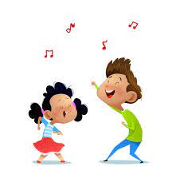 | Knowledge and skills: | I can join in singing to Nursery rhymes.  I can join in actions to Nursery rhymes.  I can tap out simple rhymes.  I begin to move rhythmically, joining in with action songs.  I can join in with singing traditional songs, and  festival songs.  I can sing to myself.  I can introduce a storyline into my play. | I can perform songs to parents and others.  I can make up a song  based on a familiar song.  I know how the sounds of  instruments can be changed eg. Loud/quiet, fast/slow | I can explore different  instruments.  I can make simple  instruments.  I can tap out a simple  repeated rhythms.  I can role play based on  my own experiences. | loud/soft  high/low  fast/slow  beat/rhythm  sing  clap  move
 | How it is taught: | Get set for music- Music scheme.  Planned adult lead activities  Planned continuous provision
Literacy |  | Autumn: | Spring: | Summer: | Key vocabulary:
Comprehension  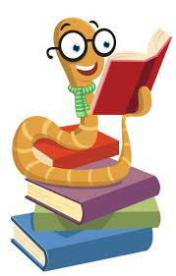 | Knowledge and skills: | I can show an interest in books and rhymes.  I participate and respond with actions, sounds,  rhythm, and repetition.  I can listen to stories supported by story sack  resources.  I can listen and talk about  rhymes.  I understand when two words start with the same sound (alliteration.) | I can identify my favourite stories, rhymes, poems,  and songs.  I can retell stories in music, movement, graphics, role play and small world play using props, costumes, and other visual supports.  I can fill in the gaps in stories and rhymes.  I am developing the use of story language, front  cover, characters, pages, writing, pictures.  I can predict key events  or phrases in a familiar  story.  I can recall main parts of  the story.  I can hold a book the  correct way up and turns  pages. | I can listen, join in with stories and poems in small  groups.  I anticipate refrains and key events.  I tell my own stories, showing awareness of their structure.  I can talk about characters and events in stories.  I am using story language recognising their name  and other familiar words.  I can handle books independently, turning pages and following text from left to right, top to  bottom, (inc. digital).  I can continue a rhyming  string. | Rhyme  Rhythm  Action  Page  Word  Picture  Where  Who  What  Character  Alliteration  Once upon a time  First  Next  last
 | How it is taught: | Daily class story  Literacy adult lead planned activities  Planned continuous provision  Phase 1 phonics
Word reading  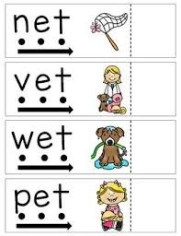 | Knowledge and skills: | I have learnt 6 key nursery rhymes: Twinkle, Twinkle, Incy Wincy,  Humpty Dumpty, Baa baa black sheep, 1,2,3,4,5,  and Hickory Dickory. | I can repeat and use actions, words, and phrases from familiar literature, signs, logos including the first letter if my name.  I recognise my own name | I am developing phonological awareness by;  clapping syllables,  orally blending,  hearing and saying initial sounds,  recognising some single letters saying their names | Phonics  Phoneme  Grapheme  Initial sound
 | How it is taught: | Literacy adult lead planned activities  Planned continuous provision/ Flashcards during carpet time  Establish and encourage book sharing between home and school.
Writing  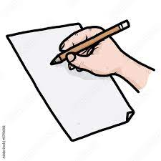 | Knowledge and skills: | I can hold a pencil, using  palmer grip in the same hand each time.  I can make making movements inside and outdoors; big, small, long, wide, quick, slow, circles, lines, dots.  I can use range of tools, large brushes, chalk, crayons, sponges, chubby pastel sticks  I can trace linear patterns and circular shapes.  I can mark make on a range of surfaces.  I can tell an adult to write my words  I can draw a circular shape and add marks within it to represent a shape. | I can distinguish between marks I make.  I can draw and write on papers, screen, and a  variety of other textures e.g., sand.  My adult can write my words and ideas  drawing attention to the words and letters with support I can add pictures.  I can co-create stories, children, and adult scribe the stories, recording them and providing  opportunities to perform or share with peers.  My drawings develop assurance, clarity, and  detail, with identifiable features  I am writing some letter shapes of importance to  me, for example, first letter of my name. | I can give meaning to my drawings and paintings.  I am starting to attempt to write words of importance to me.  I can write my own name, and some letters are formed correctly.  I am starting to use phonic knowledge when writing, adults’ model  I can hold a pencil in a pincer grip.  I can use the correct sitting position for writing. | Pencil  Draw  Write  Page  Formation
 | How it is taught: | Phonics phase 1 and 2  Literacy adult directed and independent writing opportunities  Planned continuous provision  Helicopter stories
Maths |  | Autumn: | Spring: | Summer: | Key vocabulary:
Number  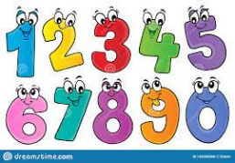 | Knowledge and skills: | Block 1: More than, fewer than, same  I can collect objects to compare amounts  I can make simple comparisons of amounts  I can look for collections of large and small amounts  I can compare and talk about large and small amounts  I can make large and small collections  I can make collections that are the same  Block 4: Hear and say number names  I can hear some number names  I can join in saying some number names  I can model saying number names in order  I can practise saying number names in order  I can join in stable order counting forwards  I can join in stable order counting backwards  Block 5: Begin to order number names  I can model saying 1, 2 and 3 in play  I can copy the sequence of 1, 2 and 3  I can copy fingers to represent 1, 2 and 3  I can count actions  I can say number names in order  I can recognise that anything can be counted  Block 6: I see 1, 2, 3  I notice images in books  I can respond to “I see 1, 2, 3”  I can recognise “I see 1, 2, 3”  I can copy “I see 1, 2, 3”  I can point to 1, 2, 3  I can recognise 1,2 3 in well known tales. | Block 9: Show me 1, 2, 3  I can copy fingers to show 1  I can copy fingers to show 2  I can copy fingers to show 3  I can show 1 finger when seeing 1 item in stories  I can show 2 or 3 fingers when seeing 2 or 3 in stories  I can show 1,2,3 on fingers when asked  Block 10: Move and label 1, 2, 3  I can make actions when saying counting words  I can move fingers when saying counting words  I can count out up to 3 objects from rhymes  I notice number symbols as labels  I can label amounts as 1 and not 1  I can label amounts as 1,2 or 3  Block 13: Take and give 1, 2, 3  I can choose a group to count  I can take out 2 from a group  I can take out 3 from a group  I can give others 2 items  I can give others 3 items  I can count 3 objects with 1:1 correspondence  Block 15: Talk about dots  I am familiar with dot patterns  I can say when there is 1 dot  I can say when there are 2 dots  I can recognise 1 and 2 in different arrangements  I can say when there are 3 dots  I can recognise 1,2 and 3 in different arrangements | Block 20: Make games and actions  I can match dot patterns  I can be introduced to subitising games  I can play subitising games  I can copy sets of sounds  I can listen to and represent sounds with fingers  I can listen to and represent sounds with resources.  Block 21: Show me 5  I can sing rhymes to 5 and join in with movements  I can move props to 5  I can move props back from 5  I can show fingers to 5  I can count 5 objects with one-to-one correspondence  I can match numerals to quantities when acting out songs  Block 23: Stop at 1, 2, 3, 4, 5  I can count out up to 5 objects from a larger group  I can explore counting to 5 in different ways  I can verbally count to a given number  I can label objects with numerals  I can independently show fingers to 5  I can make marks to represent quantities  Block 24: Match, sort, compare  I can compare up to 5 different objects  I can compare by matching  I can make the same set by matching  I can match by type  I can recognise attributes of objects  I can sort some objects into a type | More  Less  Same  Count  Add  Subtract  Big  Small  Empty  full
Numerical patterns  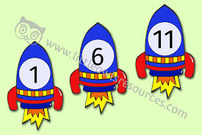 | Knowledge and skills: | Block 3: Explore repeats  I can listen to repeats in songs and stories  I can join in songs with repeats  I can join in with repeats from stories  I can clap along to songs  I can make line patterns with own sequences  I can choose blocks to build roads and towers  Block 7: Join in with repeats  I can join in with repeated actions in songs  I can join in with repeats in songs and stories  I can sing some refrains independently  I have a sense of daily routines  I can say what happens next  I can make arrangements in art | Block 12: Explore own first patterns  I can explain simple pattern arrangements  I can make roads and bridges with intent  I can choose blocks to copy simple creations  I can make simple line patterns with objects  I can make simple pattern arrangements  I can show an interest in patterns and shapes  Block 16: Compare and sort collections  I notice when two collections are the same  I can make collections of small objects the same  I can make collections of large objects the same  I can recognise two collections are the same using large and small objects  I can make collections the same using large and small objects  I can sort and talk about my own collections | Block 17: Lead on own repeats  I can join in fully with sequences and songs  I can sing rhymes independently  I can lead sequences and songs  I can read on in familiar repeating stories  I can copy art-based simple patterns  I can explore my own line and repeating patterns in art  Block 19: Making patterns together  I can sing their own songs independently  I can clap in time to a beat  I can make and talk about movement patterns  I can talk about objects in patterns and arrangements  I can copy AB patterns with support  I can continue AB patterns with support  Block 22: My own pattern  I can Continue AB patterns  I can create their own AB patterns  I can notice an error in a pattern  I can build constructions with simple enclosures  I can copy simple repeated constructions  I can sequence some events | Same  Different  More  Less  Count  Number  Pattern  Repeat  Before  After  First  Next  then
Shape space and measure  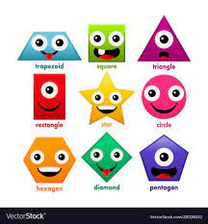 | Knowledge and skills: | Block 2: Explore and build with shapes and object  I can explore and play with shapes  I can show interest in simple differences between shapes  I can put shapes and blocks into position  I can select shapes for a reason  I can begin to explore and describe natural shapes and objects  I can find and collect objects for a purpose  Block 8: Explore position and space  I can respond to simple language of position  I can arrange blocks in a chosen position  I can select shapes for a space  I can recognise when 2 objects are the same shape  I can explore and describe shapes and objects  I can sort shapes and objects into simple categories. | Block 11: Explore position and routes  I can explore shape resources  I can explore more complex inset jigsaws  I can talk about simple positions  I can move into simple positions  I can move through positions  I can follow simple small world routes  Block 14: Match, talk, push and pull  I can match simple shapes  I can push some shapes and blocks together  I can make simple arrangements  I can talk about arrangements  I can follow simple routes outside  I can follow toys around a simple route | Block 18: Starting to puzzle  I can complete shape-match puzzles  I can complete simple jigsaws  I can match objects to pictures  I can match objects to shadows  I can explore objects and small world from different positions  I can make simple routes in small world with lines and curves | Circle.  Square  Triangle  Rectangle  Round  Sphere  Cube  Corner  Edge  Face  On  Under  Above  Below  In  Out  Beside  Next to  Near  Far  Big  Small  Long  Short  Measurement  Bigger  Smaller  Longer  Shorter  Heavy  Light  Full  Empty  More  Less  Straight  Curved  Flat  Solid  Hollow  Roll  Same  Different
 | How it is taught: | Math adult lead and independent planned activities using White Rose materials  Planned continuous provision  Flashcards during carpet time  Daily songs and rhymes  NCTM number blocks

