|  |  |  |  |  |
| --- | --- | --- | --- | --- |
| **Year 1** | | **How am I making history?** | **How have toys changed?** | **How have explorers changed the world?** |
| **Knowledge** |  |  |  |  |
| To know that a timeline shows the order events in the past happened. | **Chronological awareness** | ✔ |  | ✔ |
| To know that we start by looking at ‘now’ on a timeline then look back. | ✔ |  | ✔ |
| To know that ‘the past’ is events that have already happened. | ✔ |  | ✔ |
| To know that ‘the present’ is time happening now. | ✔ |  | ✔ |
| To know that within living memory is 100 years. | ✔ |  | ✔ |
| **Skills** |  |  |  |
| Sequencing three or four events in their own life | ✔ |  |  |
| Using common words and phrases for the passing of time (e.g. now, long ago, then, before, after) | ✔ | ✔ | ✔ |
| Sequencing three or four artefacts from different periods of time. |  | ✔ |  |
| Placing events on a simple timeline. | ✔ |  | ✔ |
| Recording on a timeline a sequence of historical stories heard orally. |  |  | ✔ |

|  |  |  |  |  |
| --- | --- | --- | --- | --- |
| **Year 1** | **Disciplinary concepts:** | **How am I making history?** | **How have toys changed?** | **How have explorers changed the world?** |
| **Knowledge** |  |  |  |  |
| To know that people change as they grow older. | Change and continuity | ✔ |  |  |
| To know that throughout someone’s lifetime, some things will change and some things will stay the same. | ✔ | ✔ |  |
| To know that everyday objects have changed over time. |  | ✔ |  |
| To know that everyday objects have changed as new materials have been invented. | Cause and consequence |  | ✔ |  |
| To know that there are similarities and differences between their lives today and their lives in the past. | Similarities and differences | ✔ |  | ✔ |
| To know some similarities and differences between the past and their own lives. | ✔ | ✔ | ✔ |
| To know that people celebrate special events in different ways. | ✔ |  |  |
| To know that everyday objects have similarities and differences with those used for the same purpose in the past. |  | ✔ |  |
| To know that some people and events are considered more ‘special’ or significant than others. | Historical significance | ✔ |  | ✔ |
| To know that photographs can tell us about the past. | Sources of evidence | ✔ |  | ✔ |
| To know that we can find out about the past by asking people who were there. | ✔ | ✔ |  |
| To know that artefacts can tell us about the past. |  | ✔ |  |
| To know that we remember some (but not all) of the events that we have lived through. | ✔ | ✔ |  |
| To know that the past can be represented in photographs. | Historical interpretations | ✔ | ✔ | ✔ |

|  |  |  |  |  |
| --- | --- | --- | --- | --- |
| **Year 1** | **Disciplinary concepts:** | **How am I making history?** | **How have toys changed?** | **How have explorers changed the world?** |
| **Skills** |  |  |  |  |
| Being aware that some things have changed and some have stayed the same in their own lives. | Change and continuity | ✔ | ✔ |  |
| Describing simple changes and ideas/objects that remain the same. | ✔ | ✔ | ✔ |
| Understanding that some things change while other items remain the same and some are new. | ✔ | ✔ | ✔ |
| Asking why things happen and beginning to explain why with support. | Cause and consequence |  | ✔ | ✔ |
| Beginning to look for similarities and differences over time in their own lives. | Similarities and differences | ✔ | ✔ |  |
| Recalling special events in their own lives. | Historical significance | ✔ | ✔ |  |
| Using artefacts, photographs and visits to museums to answer simple questions about the past. | Sources of evidence | ✔ | ✔ | ✔ |
| Finding answers to simple questions about the past using sources (e.g. artefacts). |  | ✔ | ✔ |
| Sorting artefacts from then and now. |  | ✔ |  |
| Beginning to identify different ways to represent the past (e.g. photos, stories). | Historical interpretations | ✔ | ✔ | ✔ |
| Developing their own interpretations from historical artefacts. |  | ✔ |  |

|  |  |  |  |  |
| --- | --- | --- | --- | --- |
| **Year 1** | **Historical enquiry** | **How am I making history?** | **How have toys changed?** | **How have explorers changed the world?** |
| **Skills** |  |  |  |  |
| Asking how and why questions based on stories, events and people. | Posing historical questions | ✔ | ✔ | ✔ |
| Asking questions about sources of evidence (e.g.  artefacts). |  | ✔ | ✔ |
| Using sources of information, such as artefacts, to answer questions. | Gathering, organising and evaluating evidence |  | ✔ | ✔ |
| Drawing out information from sources. |  | ✔ | ✔ |
| Making simple observations about the past from a source. | ✔ | ✔ | ✔ |
| Interpreting evidence by making simple deductions. . | Interpreting findings, analysing and making connections | ✔ | ✔ | ✔ |
| Making simple inferences and deductions from sources of evidence. |  | ✔ | ✔ |
| Describing the main features of concrete evidence of |  |  |  |
| the past or historical evidence. |  | ✔ | ✔ | ✔ |
| Drawing simple conclusions to answer a question. | Evaluating and drawing conclusions |  | ✔ | ✔ |
| Communicating findings through discussion and timelines with physical objects/ pictures. | Communicating findings | ✔ | ✔ | ✔ |
| Using vocabulary such as - old, new, long time ago. | ✔ | ✔ | ✔ |
| Discussing and writing about past events or stories in narrative or dramatic forms. |  |  | ✔ |
| Expressing a personal response to a historical story or event. |  |  | ✔ |

|  |  |  |  |  |
| --- | --- | --- | --- | --- |
| **Year 1** | **Substantive concepts:** | **How am I making history?** | **How have toys changed?** | **How have explorers changed the world?** |
| **Knowledge** |  |  |  |  |
| To know some inventions that still influence their own lives today. | Achievements and follies of mankind |  | ✔ | ✔ |
| To know some achievements and discoveries of significant individuals. |  |  | ✔ |
|  |

|  |  |  |  |  |
| --- | --- | --- | --- | --- |
| **Year 2** | | **How was school different in the past?** | **How did we learn to fly?** | **What is a monarch?** |
| To know a decade is ten years. | **Chronological awareness** | ✔ |  |  |
| To know that beyond living memory is more than 100 years ago. | ✔ | ✔ | ✔ |
| To know that events in history may last different amounts of time.  ○ |  |  | ✔ |
| Sequencing up to six photographs, focusing on the intervals between events. | ✔ | ✔ | ✔ |
| Placing events on a timeline, building on times studied in Year 1. |  | ✔ | ✔ |
| Beginning to recognise how long each event lasted. |  | ✔ | ✔ |
| Knowing where people/events studied fit into a chronological framework. | ✔ | ✔ | ✔ |

|  |  |  |  |  |
| --- | --- | --- | --- | --- |
| **Year 2** | **Disciplinary concepts:** | **How was school different in the past?** | **How did we learn to fly?** | **What is a monarch?** |
| To know that daily life has changed over time but that there are some similarities to life today. | Change and continuity | ✔ |  |  |
| To know that changes may come about because of improvements in technology. | Cause and consequence | ✔ | ✔ |  |
| To know that there are explanations for similarities and differences between children’s lives now and in the past. | Similarities and differences | ✔ |  |  |
| To know that some events are more significant than others. | Historical significance |  | ✔ | ✔ |
| To know the impact of a historical event on society. |  | ✔ | ✔ |
| To know that ‘historically significant’ people are those who changed many people’s lives. |  | ✔ | ✔ |
| To know that we can find out about how places have changed by looking at maps. | Sources of evidence | ✔ |  |  |
| To know that historians use evidence from sources to find out more about the past. | ✔ | ✔ | ✔ |
| To know that the past is represented in different ways | Historical interpretations |  | ✔ | ✔ |

|  |  |  |  |  |
| --- | --- | --- | --- | --- |
| **Year 2** | **Disciplinary concepts:** | **How was school different in the past?** | **How did we learn to fly?** | **What is a monarch?** |
| Recognising some things which have changed/stayed the same as the past. | Change and continuity | ✔ | ✔ | ✔ |
| Identifying simple reasons for changes. | ✔ | ✔ | ✔ |
| Asking questions about why people did things, why events happened and what happened as a result. | Cause and consequence |  | ✔ | ✔ |
| Recognising why people did things, why events happened and what happened as a result. |  | ✔ | ✔ |
| Identifying similarities and difference between ways of life at different times. | Similarities and differences | ✔ |  | ✔ |
| Finding out about people, events and beliefs in society. | ✔ | ✔ | ✔ |
| Making comparisons with their own lives. | ✔ |  |  |
| Discussing who was important in a historical event. | Historical significance |  | ✔ | ✔ |
| Using artefacts, photographs and visits to museums to ask and answer questions about the past. | Sources of evidence | ✔ | ✔ | ✔ |
| Making simple observations about a source or artefact. | ✔ | ✔ | ✔ |
| Using sources to show an understanding of historical concepts (see above). | ✔ | ✔ | ✔ |
| Identifying a primary source. |  | ✔ |  |
| Recognising different ways in which the past is represented (including eye-witness accounts). | Historical interpretations | ✔ | ✔ | ✔ |
| Comparing pictures or photographs of people or events in the past. | ✔ | ✔ | ✔ |
| Developing their own interpretations from photographs and written sources. | ✔ | ✔ |  |

|  |  |  |  |  |
| --- | --- | --- | --- | --- |
| **Year 2** | **Historical enquiry** | **How was school different in the past?** | **How did we learn to fly?** | **What is a monarch?** |
| Asking a range of questions about stories, events and people. | Posing historical questions | ✔ | ✔ | ✔ |
| Understanding the importance of |  |  |  |
| historically-valid questions. |  | ✔ | ✔ | ✔ |
| Understanding how we use books and sources to find out about the past. | Gathering, organising and evaluating evidence | ✔ | ✔ | ✔ |
| Using a source to answer questions about the past. | ✔ | ✔ | ✔ |
| Evaluating the usefulness of sources to a historical enquiry. | ✔ | ✔ | ✔ |
| Selecting information from a source to answer a question. | ✔ | ✔ | ✔ |
| Identifying a primary source. |  | ✔ |  |
| Making links and connections across a unit of study. | Interpreting findings, analysing and making connections | ✔ | ✔ | ✔ |
| Selecting and using sections of sources to illustrate and support answers. |  | ✔ |  |

|  |  |  |  |  |
| --- | --- | --- | --- | --- |
| **Year 2** | **Historical enquiry** | **How was school different in the past?** | **How did we learn to fly?** | **What is a monarch?** |
| Making simple conclusions about a question using evidence to support. | Evaluating and drawing conclusions | ✔ | ✔ | ✔ |
| Communicating answers to questions in a variety of ways, including discussion, drama and writing (labelling, simple recount). | Communicating findings | ✔ | ✔ | ✔ |
| Using relevant vocabulary in answers. | ✔ | ✔ | ✔ |
| Describing past events and people by drawing or writing. | ✔ | ✔ | ✔ |
| Expressing a personal response to a historical story or event through discussion, drawing our writing. | ✔ | ✔ |  |

|  |  |  |  |  |
| --- | --- | --- | --- | --- |
| **Year 2** | **Substantive concepts:** | **How was school different in the past?** | **How did we learn to fly?** | **What is a monarch?** |
| To know that a monarch in the UK is a king or queen. | Power (monarchy, government and empire) |  |  | ✔ |
| To begin to understand that power is exercised in different ways in different culture, times and groups e.g. monarchy. |  |  | ✔ |
|  |  |  |  |
| To know that Britain was organised into kingdoms and these were governed by monarchs. |  |  |  | ✔ |
| To begin to identify achievements and inventions that still influence their own lives today. | Achievements and follies of mankind |  | ✔ |  |
| To know the legacy and contribution of the inventions. |  | ✔ |  |
| To be aware of the achievements of significant individuals. |  | ✔ | ✔ |

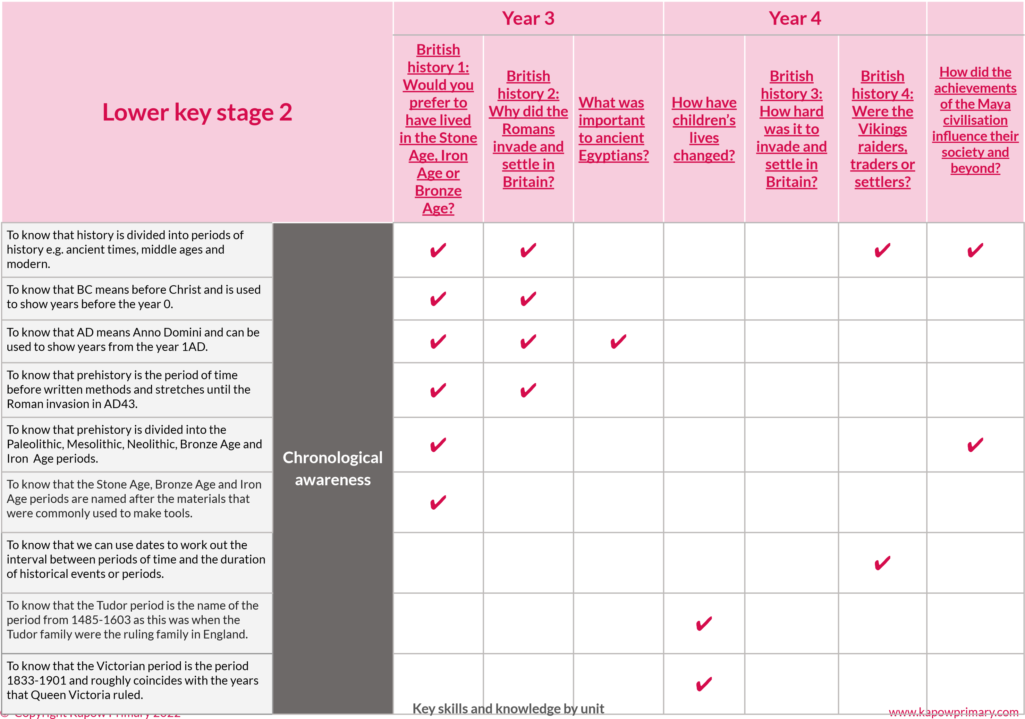

|  |  |  |  |  |  |  |  |  |
| --- | --- | --- | --- | --- | --- | --- | --- | --- |
| **Lower key stage 2** | | **Year 3** | | | **Year 4** | | |  |
| **British history 1:**  **Would you prefer to**  **have lived**  **in the Stone**  **Age, Iron**  **Age or**  **Bronze Age?** | **British history 2:**  **Why did the Romans**  **invade and settle in Britain?** | **What was important to ancient**  **Egyptians?** | **How have children’s lives changed?** | **British history 3:**  **How hard was it to**  **invade and settle in Britain?** | **British history 4:**  **Were the Vikings raiders,**  **traders or settlers?** | **How did the achievements of the Maya civilisation**  **influence their society and beyond?** |
| Sequencing events on a timeline, referring to times studied in KS1 to see where these fit in. | **Chronological awareness** | ✔ |  | ✔ |  | ✔ | ✔ | ✔ |
| Understanding that history is divided into periods of history e.g. ancient times, middle ages and modern. | ✔ | ✔ | ✔ | ✔ | ✔ | ✔ | ✔ |
| Using dates to work out the interval between periods of time and the duration of historical events or periods. | ✔ | ✔ | ✔ | ✔ | ✔ | ✔ |  |
| Using BC/AD/Century. | ✔ | ✔ | ✔ |  | ✔ | ✔ | ✔ |
| Sequencing eight to ten artefacts, historical pictures or events. |  |  | ✔ | ✔ |  |  | ✔ |
| Beginning to develop a chronologically secure knowledge of local, British and world history across the periods studied. | ✔ | ✔ | ✔ | ✔ | ✔ | ✔ | ✔ |
| Placing the time studied on a timeline. | ✔ | ✔ | ✔ | ✔ | ✔ | ✔ | ✔ |
| Using dates and terms related to the unit and passing of time e.g. millennium, continuity and ancient. | ✔ | ✔ | ✔ | ✔ | ✔ | ✔ | ✔ |
| Noticing connections over a period of time. | ✔ | ✔ | ✔ | ✔ | ✔ | ✔ | ✔ |
| Making a simple individual timeline.  © Copyright Kapow Primary 2022 | **Key skills a** | ✔  **nd knowledge** | ✔ **by unit** | ✔ | ✔ | ✔ | ✔ www.kapowprimary.com |

|  |  |  |  |  |  |  |  |  |
| --- | --- | --- | --- | --- | --- | --- | --- | --- |
| **Lower key stage 2** | **Disciplinary concepts:** | **Year 3** | | | **Year 4** | | |  |
| **British history 1:**  **Would you prefer to**  **have lived**  **in the Stone**  **Age, Iron**  **Age or**  **Bronze Age?** | **British history 2:**  **Why did the**  **Romans invade and settle in Britain?** | **What was important to ancient**  **Egyptians?** | **How have children’s lives changed?** | **British history 3:**  **How hard was it to**  **invade and settle in Britain?** | **British history 4:**  **Were the Vikings raiders,**  **traders or settlers?** | **How did the achievements of the Maya civilisation**  **influence their society and beyond?** |
| To know that change can be brought about by advancements in transport and travel. | Change and continuity | ✔ |  |  |  |  |  |  |
| To know that change can be brought about by advancements in materials. | ✔ | ✔ |  |  |  |  | ✔ |
| To know that change can be brought about by advancements in trade | ✔ |  | ✔ |  |  | ✔ | ✔ |
| |  |  | | --- | --- | | To know that the actions of people can be the | | | cause of change (eg. Lord Shaftesbury). |  | | Cause and consequence |  | ✔ |  | ✔ |  |  | ✔ |
| To know that advancements in science and technology can be the cause of change. |  |  |  | ✔ |  | ✔ | ✔ |
| To know that significant archaeological findings are those which change how we see the past. | Historical significance | ✔ |  | ✔ |  | ✔ |  | ✔ |
| To know that ‘historically significant’ events are those which changed many people’s lives and had an impact for many years to come. |  | ✔ |  | ✔ | ✔ | ✔ | ✔ |
| To know that archaeological evidence can be used to find out about the past. | Sources of evidence | ✔ | ✔ | ✔ |  |  | ✔ | ✔ |
| To know that we can make inferences and deductions using images from the past. | ✔ | ✔ | ✔ | ✔ | ✔ | ✔ | ✔ |
| To know that archaeological evidence has limitations: it does not give all the answers or tell us about the emotions of people from the past. | Historical interpretations | ✔ |  | ✔ |  |  |  | ✔ |
| To know that assumptions made by historians can change in the light of new evidence.  © Copyright Kapow Primary 2022 | ✔ | **Key skills and knowledge by unit** | ✔ | ✔ |  | ✔  ww | ✔  w.kapowprimary.com |

|  |  |  |  |  |  |  |  |  |  |  |
| --- | --- | --- | --- | --- | --- | --- | --- | --- | --- | --- |
| **Lower key stage 2** | **Disciplinary concepts:** | **Year 3** | | | **Year 4** | | | |  | |
| **British history 1:**  **Would you prefer to**  **have lived**  **in the Stone**  **Age, Iron**  **Age or**  **Bronze Age?** | **British history 2:**  **Why did the Romans**  **invade and settle in Britain?** | **What was important to ancient**  **Egyptians?** | **How have children’s lives changed?** | **British history 3:**  **How hard was it to**  **invade and settle in Britain?** | | **British history 4:**  **Were the Vikings raiders,**  **traders or settlers?** | **How did the achievements of the Maya civilisation**  **influence their society and beyond?** | |
| Identifying reasons for change and reasons for continuities. | Change and continuity | ✔ |  | ✔ | ✔ | ✔ | |  |  | |
| Identifying what the situation was like before the change occurred. | ✔ | ✔ | ✔ | ✔ | ✔ | | ✔ | ✔ | |
| Comparing different periods of history and identifying changes and continuity. | ✔ | ✔ | ✔ | ✔ | ✔ | | ✔ | ✔ | |
| Describing the changes and continuity between different periods of history. | ✔ | ✔ | ✔ | ✔ | ✔ | |  | ✔ | |
| Identifying the links between different societies. | ✔ | ✔ | ✔ |  | ✔ | | ✔ | ✔ | |
| Identifying the consequences of events and the actions of people. | Cause and consequence |  | ✔ | ✔ | ✔ | ✔ | | ✔ | ✔ | |
| Identifying reasons for historical events, situations and changes. | ✔ | ✔ | ✔ | ✔ | ✔ | | ✔ | ✔ | |
| Identifying similarities and differences between periods of history. | Similarities and differences | ✔ | ✔ |  | ✔ | ✔ | |  | ✔ | |
| Explaining similarities and differences between daily lives of people in the past and today. | ✔ | ✔ |  | ✔ | ✔ | |  | ✔ | |
| Identifying similarities and differences between social, cultural, religious and ethnic diversity in Britain and the wider world.  © Copyright Kapow Primary 2022 | ✔  **Key skills a** | ✔  **nd knowledge** | **by unit** |  | ✔ | |  | ✔  www.kapowprimary.com | |
| **Lower key stage 2** | **Disciplinary concepts:** | **Year 3** | | | **Year 4** | | | | |  |
| **British history 1:**  **Would you prefer to**  **have lived**  **in the Stone**  **Age, Iron**  **Age or**  **Bronze Age?** | **British history 2:**  **Why did the Romans**  **invade and settle in Britain?** | **What was important to ancient**  **Egyptians?** | **How have children’s lives changed?** | **British history 3:**  **How hard was it to invade**  **and settle in Britain?** | **British history 4:**  **Were the Vikings raiders,**  **traders or settlers?** | | | **How did the achievements of the Maya civilisation**  **influence their society and beyond?** |
| Recalling some important people and events. | Historical significance |  | ✔ |  | ✔ | ✔ |  | | | ✔ |
| Identifying who is important in historical sources and accounts. |  | ✔ |  | ✔ | ✔ | ✔ | | |  |
| Using a range of sources to find out about a period. | Sources of evidence | ✔ | ✔ | ✔ | ✔ | ✔ | ✔ | | | ✔ |
| Using evidence to build up a picture of a past event. | ✔ | ✔ | ✔ | ✔ | ✔ | ✔ | | | ✔ |
| Observing the small details when using artefacts and pictures. | ✔ | ✔ | ✔ | ✔ | ✔ |  | | | ✔ |
| Identifying sources which are influenced by the personal beliefs of the author. |  |  |  | ✔ |  | ✔ | | |  |
| Identifying and giving reasons for different ways in which the past is represented. | Historical interpretations |  |  |  | ✔ | ✔ | ✔ | | | ✔ |
| Identifying the differences between different sources and giving reasons for the ways in which the past is represented. |  | ✔ |  | ✔ |  | ✔ | | |  |
| Exploring different representations from the period e.g. archaeological evidence, museum evidence, cartoons and books. | ✔ | ✔ | ✔ |  | ✔ | ✔ | | | ✔ |
| Evaluating the usefulness of different sources. | ✔ | ✔ |  | ✔ | ✔ | ✔ | | |  |

© Copyright Kapow Primary 2022 **Key skills and knowledge by unit**  www.kapowprimary.com

|  |  |  |  |  |  |  |  |  |  |  |
| --- | --- | --- | --- | --- | --- | --- | --- | --- | --- | --- |
| **Lower key stage 2** | **Historical enquiry** | **Year 3** | | | **Year 4** | | | |  | |
| **British history 1:**  **Would you prefer to**  **have lived**  **in the Stone**  **Age, Iron**  **Age or**  **Bronze Age?** | **British history 2:**  **Why did the Romans**  **invade and settle in Britain?** | **What was important to ancient**  **Egyptians?** | **How have children’s lives changed?** | **British history 3:**  **How hard was it to**  **invade and settle in Britain?** | | **British history 4:**  **Were the Vikings raiders,**  **traders or settlers?** | **How did the achievements of the Maya civilisation influence**  **their society and beyond?** | |
| Understanding how historical enquiry questions are structured. | Posing historical questions |  |  | ✔ | ✔ | ✔ | | ✔ |  | |
| Creating historically-valid questions across a range of time periods, cultures and groups of people. |  |  | ✔ | ✔ | ✔ | | ✔ | ✔ | |
| Asking questions about the main features of everyday life in periods studied, e.g. how did people live. | ✔ | ✔ | ✔ | ✔ | ✔ | |  | ✔ | |
| Creating questions for different types of historical enquiry. |  |  |  | ✔ |  | | ✔ |  | |
| Asking questions about the bias of historical evidence. |  | ✔ |  | ✔ | ✔ | | ✔ |  | |
| Using a range of sources to construct knowledge of the past. | Gathering, organising and  evaluating evidence | ✔ | ✔ | ✔ | ✔ | ✔ | | ✔ | ✔ | |
| Defining the terms ‘source’ and ‘evidence’. |  | ✔ | ✔ | ✔ | ✔ | | ✔ |  | |
| Extracting the appropriate information from a historical source. | ✔ | ✔ | ✔ | ✔ | ✔ | | ✔ | ✔ | |
| Selecting and recording relevant information from a range of sources to answer a question.  © Copyright Kapow Primary 2022 | **Key skills a** | ✔  **nd knowledge** | ✔  **by unit** | ✔ |  | | ✔ | ✔  www.kapowprimary.com | |
| **Lower key stage 2** | **Historical enquiry** | **Year 3** | | | **Year 4** | | | | |  |
| **British history 1:**  **Would you prefer to**  **have lived**  **in the Stone**  **Age, Iron**  **Age or**  **Bronze Age?** | **British history 2:**  **Why did the Romans**  **invade and settle in Britain?** | **What was important to ancient**  **Egyptians?** | **How have children’s lives changed?** | | **British history 3:**  **How hard was it to**  **invade and settle in Britain?** | **British history 4:**  **Were the Vikings raiders,**  **traders or settlers?** | | **How did the achievements of the Maya civilisation influence**  **their society and beyond?** |
| Identifying primary and secondary sources. | Gathering, organising and  evaluating evidence  (continued…) | ✔ | ✔ |  | ✔ | | ✔ | ✔ | |  |
| Identifying the bias of a source. |  |  |  | ✔ | | ✔ | ✔ | |  |
| Comparing and contrasting different historical sources. |  |  |  | ✔ | | ✔ | ✔ | | ✔ |
| Understanding that there are different ways to interpret evidence. | Interpreting findings,  analysing and making connections |  | ✔ | ✔ |  | | ✔ | ✔ | | ✔ |
| Interpreting evidence in different ways. | ✔ |  | ✔ |  | |  | ✔ | | ✔ |
| Understanding and making deductions from documentary as well as concrete evidence e.g. pictures and artefacts. | ✔ | ✔ | ✔ | ✔ | | ✔ | ✔ | | ✔ |
| Making links and connections across a period of time, cultures or groups. | ✔ | ✔ | ✔ | ✔ | | ✔ | ✔ | | ✔ |
| Asking the question “How do we know?” | ✔ | ✔ | ✔ | ✔ | | ✔ | ✔ | |  |

© Copyright Kapow Primary 2022 **Key skills and knowledge by unit**  www.kapowprimary.com

|  |  |  |  |  |  |  |  |  |
| --- | --- | --- | --- | --- | --- | --- | --- | --- |
| **Lower key stage 2** | **Historical enquiry** | **Year 3** | | | **Year 4** | | |  |
| **British history 1:**  **Would you prefer to**  **have lived**  **in the Stone**  **Age, Iron**  **Age or**  **Bronze Age?** | **British history 2:**  **Why did the Romans**  **invade and settle in Britain?** | **What was important to ancient**  **Egyptians?** | **How have children’s lives changed?** | **British history 3:**  **How hard was it to**  **invade and settle in Britain?** | **British history 4:**  **Were the Vikings raiders,**  **traders or settlers?** | **How did the achievements of the Maya civilisation**  **influence their society and beyond?** |
| Understanding that there may be multiple conclusions to a historical enquiry question. | Evaluating and drawing conclusions |  |  | ✔ |  | ✔ | ✔ | ✔ |
| Reaching conclusions that are substantiated by historical evidence. | ✔ | ✔ | ✔ |  | ✔ | ✔ | ✔ |
| Recognising similarities and differences between past events and today. |  |  | ✔ | ✔ |  |  | ✔ |
| Communicating knowledge and understanding through discussion, debates, drama, art and writing. | Communicati ng findings |  | ✔ |  | ✔ | ✔ | ✔ | ✔ |
| Constructing answers using evidence to substantiate findings. | ✔ | ✔ | ✔ | ✔ | ✔ | ✔ | ✔ |
| Identifying weaknesses in historical accounts and arguments. | ✔ | ✔ |  |  | ✔ | ✔ | ✔ |
| Creating a simple imaginative reconstruction of a past event using the evidence available to draw, model, dramatise, write or retell the story. |  |  | ✔ |  | ✔ |  | ✔ |
| Creating a structured response or narrative to answer a historical enquiry. | ✔ | ✔ | ✔ | ✔ | ✔ | ✔ | ✔ |
| Describing past events orally or in writing, recognising similarities and differences with © Copyright Kapow Primary 2022today. | ✔  **Key skills a** | **nd knowledge** | **by unit** | ✔ |  | ✔ | ✔ www.kapowprimary.com |

|  |  |  |  |  |  |  |  |  |
| --- | --- | --- | --- | --- | --- | --- | --- | --- |
| **Lower key stage 2** | **Substantive concepts:** | **Year 3** | | | **Year 4** | | |  |
| **British history 1:**  **Would you prefer to**  **have lived in the Stone**  **Age, Iron**  **Age or**  **Bronze Age?** | **British history 2:**  **Why did the**  **Romans invade and settle in Britain?** | **What was important to ancient**  **Egyptians?** | **How have children’s lives changed?** | **British history 3:**  **How hard was it to**  **invade and settle in Britain?** | **British history 4:**  **Were the Vikings raiders,**  **traders or settlers?** | **How did the achievements of the Maya civilisation influence**  **their society and beyond?** |
| To understand the development of groups, kingdom and monarchy in Britain. | Power  (monarchy, government and empire) | ✔ |  |  |  | ✔ | ✔ |  |
| To know who became the first ruler of the whole of England. |  |  |  |  | ✔ | ✔ |  |
| To understand the expansion of empires and how they were controlled across a large empire. |  | ✔ |  |  |  |  |  |
| To understand that societal hierarchies and structures existed including aristocracy and peasantry. |  | ✔ | ✔ |  | ✔ |  |  |
| To understand some reasons why empires fall/collapse. |  | ✔ |  |  |  |  |  |
| To know that there were different reasons for invading Britain. | Invasion, settlement and migration |  | ✔ |  |  | ✔ | ✔ |  |
| To understand that there are varied reasons for coming to Britain. | ✔ | ✔ |  |  | ✔ | ✔ |  |
| To know that there are different reasons for migration. |  |  |  |  | ✔ | ✔ |  |
| To know that settlement created tensions and problems. |  | ✔ |  |  | ✔ | ✔ |  |
| To understand the impact of settlers on the existing population. |  | ✔ |  |  | ✔ | ✔ |  |
| To understand the earliest settlements in Britain. | ✔ | ✔ |  |  | ✔ |  |  |
| To know that settlements changed over time. © Copyright Kapow Primary 2022 | ✔ |  |  |  | ✔ | www.kapo | ✔ wprimary.com |

**Key skills and knowledge by unit 27**

|  |  |  |  |  |  |  |  |  |
| --- | --- | --- | --- | --- | --- | --- | --- | --- |
| **Lower key stage 2** | **Substantive concepts:** | **Year 3** | | | **Year 4** | | |  |
| **British history 1:**  **Would you prefer to**  **have lived in the Stone**  **Age, Iron**  **Age or**  **Bronze Age?** | **British history 2:**  **Why did the**  **Romans invade and settle in Britain?** | **What was important to ancient**  **Egyptians?** | **How have children’s lives changed?** | **British history 3:**  **How hard was it to**  **invade and settle in Britain?** | **British history 4:**  **Were the Vikings raiders,**  **traders or settlers?** | **How did the achievements of the Maya civilisation influence**  **their society and beyond?** |
| To understand how invaders and settlers influence the culture of the existing population. | Civilisation  (social and cultural) | ✔ | ✔ |  |  | ✔ | ✔ |  |
| To understand that society was organised in different ways in different cultures and times and consisted of different groups with different roles and lifestyles. | ✔ | ✔ | ✔ | ✔ | ✔ | ✔ | ✔ |
| To know that education existed in some cultures, times and groups. |  |  |  | ✔ |  |  | ✔ |
| To know that communities traded with each other and over the English Channel in the Prehistoric Period. | Trade | ✔ | ✔ |  |  | ✔ | ✔ |  |
| To understand that trade began as the exchange of goods. | ✔ | ✔ |  |  |  | ✔ | ✔ |
| To understand that trade routes existed between Britain in the Roman, Anglo-Saxon and Viking times. | ✔ | ✔ |  |  |  | ✔ |  |
| To understand that the Roman invasion led to a great increase in British trade with the outside world. |  | ✔ |  |  |  |  |  |
| To understand that trading ships and centres (e.g. York) were a reason for the Vikings raiding Britain. |  |  |  |  |  | ✔ |  |
| To understand that trade develops in different times and ways in different civilisations. | ✔ | ✔ |  |  |  | ✔ |  |
| © Copyright KapowTo understand that the traders were the rich Primary 2022 members of society. | **Key skills a** ✔ | **nd knowledge b** | **y unit** |  |  | www.kapo  ✔ | wprimary.com |

|  |  |  |  |  |  |  |  |  |
| --- | --- | --- | --- | --- | --- | --- | --- | --- |
| **Lower key stage 2** | **Substantive concepts:** | **Year 3** | | | **Year 4** | | |  |
| **British history 1:**  **Would you prefer to**  **have lived in**  **the Stone**  **Age, Iron**  **Age or**  **Bronze Age?** | **British history 2:**  **Why did the**  **Romans invade and settle in Britain?** | **What was important to ancient**  **Egyptians?** | **How have children’s lives changed?** | **British history 3:**  **How hard was it to**  **invade and settle in Britain?** | **British history 4:**  **Were the Vikings raiders,**  **traders or settlers?** | **How did the achievements of the Maya civilisation**  **influence their society and beyond?** |
| To understand that there are different beliefs in different cultures, times and groups. | Beliefs |  | ✔ | ✔ |  | ✔ |  | ✔ |
| To know about paganism and and the introduction of Christianity in Britain. |  | ✔ |  |  | ✔ | ✔ |  |
| To know how Christianity spread. |  |  |  |  | ✔ |  |  |
| To compare the beliefs in different cultures, times and groups. |  |  | ✔ |  | ✔ | ✔ | ✔ |
| To be able to identify achievements and inventions that still influence our lives today from Roman times. | Achievements and follies of mankind |  | ✔ |  |  |  |  |  |
| To know the legacy and contribution of the  Anglo-Saxons and Vikings to life today in Britain. |  |  |  |  | ✔ | ✔ |  |
| To be aware that the achievements of ancient civilisations contributed to the development of technology, culture and science. |  |  | ✔ |  |  |  | ✔ |

|  |  |  |  |  |  |  |  |  |
| --- | --- | --- | --- | --- | --- | --- | --- | --- |
| **Upper key stage 2** | | **Year 5** | | | **Year 6** | | | |
| **British history 5:**  **What was life like in**  **Tudor**  **England?** | **What is the legacy of**  **the ancient**  **Greek**  **civilisation?** | **How did the**  **Maya**  **civilisation**  **compare to the AngloSaxons?** | **What can the census**  **tell us about local areas?** | **British history 6:**  **What was the impact of World**  **War II on the people of Britain?** | Choose one of: | |
| **Unheard**  **histories:**  **Who should go on the banknote?** | **The Sikh Empire** |
| To understand the term “century” and how dating by centuries works. (e.g. the 1500s are known as the 16th century) | **Chronological awareness** |  | ✔ |  |  |  |  |  |
| To know relevant dates and relevant terms for the period and period labels e.g. Stone Age, Bronze Age, Iron Age, Romans, Anglo-Saxons, Vikings, Romans, Tudors, Greeks, Maya , and Victorians. | ✔ | ✔ | ✔ |  |  |  |  |
| To understand that historical periods have characteristics that distinguish them. | ✔ | ✔ | ✔ |  | ✔ |  |  |
| To understand how to work out durations of periods and events. | ✔ | ✔ | ✔ |  | ✔ |  |  |
| To understand how to represent a scale on a timeline. |  | ✔ | ✔ |  | ✔ |  |  |
| To understand how to create their own timeline selecting significant events. |  | ✔ | ✔ |  | ✔ |  |  |

|  |  |  |  |  |  |  |  |  |
| --- | --- | --- | --- | --- | --- | --- | --- | --- |
| **Upper key stage 2** | | **Year 5** | | | **Year 6** | | | |
| **British history 5:**  **What was life like in**  **Tudor**  **England?** | **What is the legacy of**  **the ancient**  **Greek**  **civilisation?** | **How did the**  **Maya**  **civilisation**  **compare to the AngloSaxons?** | **What can the census**  **tell us about local areas?** | **British history 6:**  **What was the impact of World**  **War II on the people of Britain?** | Choose one of: | |
| **Unheard**  **histories:**  **Who should go on the banknote?** | **The Sikh Empire** |
| Sequencing events on a timeline, comparing where it fits in with times studied in previous year groups. | **Chronological awareness** | ✔ | ✔ | ✔ | ✔ | ✔ |  |  |
| Putting dates in the correct century. | ✔ |  | ✔ |  |  | ✔ | ✔ |
| Using the terms AD and BC in their work. | ✔ | ✔ | ✔ |  |  |  |  |
| Using relevant dates and relevant terms for the period and period labels e.g.Stone Age, Bronze Age, Iron Age |  | ✔ | ✔ | ✔ |  |  |  |
| Developing a chronologically secure understanding of British, local and world history across the periods studied. | ✔ | ✔ | ✔ |  | ✔ |  | ✔ |
| Placing the time, period of history and context on a timeline. | ✔ | ✔ | ✔ |  | ✔ |  |  |
| Relating current study on timeline to other periods of history studied. | ✔ | ✔ | ✔ | ✔ |  |  |  |
| Comparing and making connections between different contexts in the past. | ✔ | ✔ | ✔ | ✔ | ✔ | ✔ | ✔ |

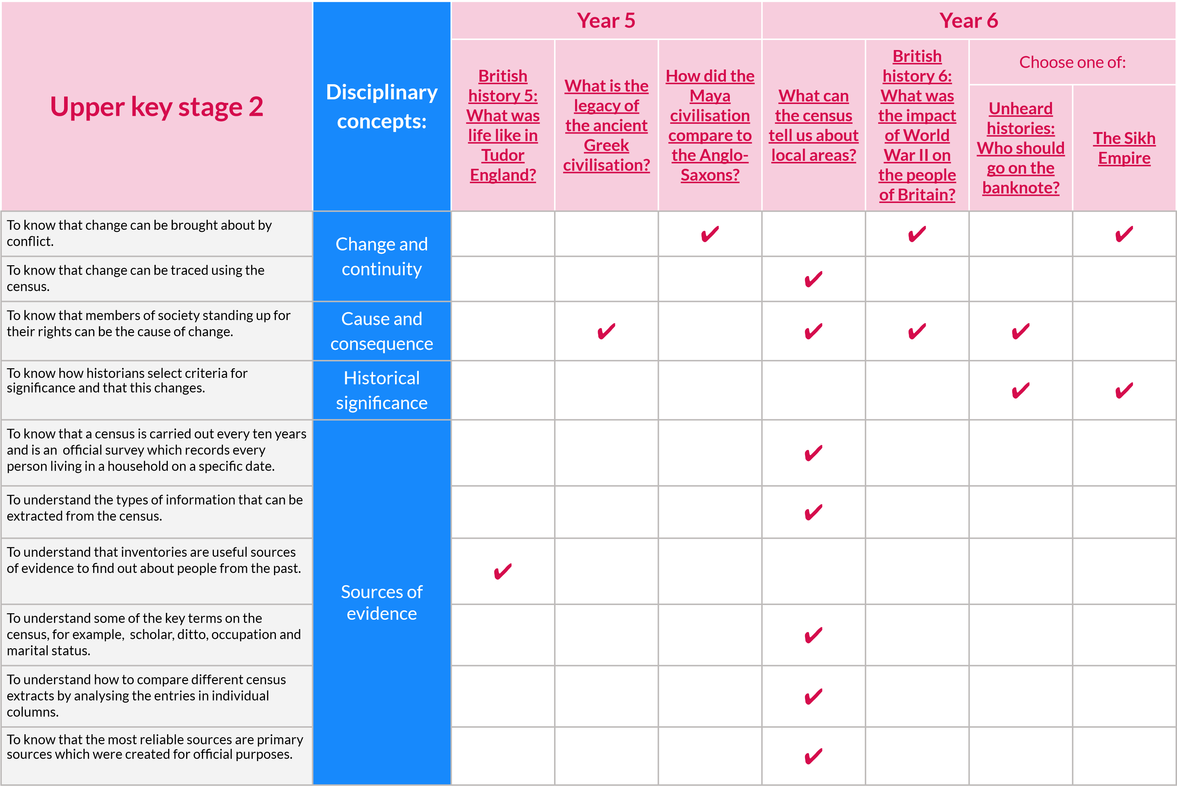

|  |  |  |  |  |  |  |  |  |
| --- | --- | --- | --- | --- | --- | --- | --- | --- |
| **Upper key stage 2** | **Disciplinary concepts:** | **Year 5** | | | **Year 6** | | | |
| **British history 5:**  **What was life like in**  **Tudor**  **England?** | **What is the legacy of**  **the ancient**  **Greek**  **civilisation?** | **How did the**  **Maya**  **civilisation**  **compare to the AngloSaxons?** | **What can the census**  **tell us about local areas?** | **British history 6:**  **What was the impact of World**  **War II on the people of Britain?** | Choose one of: | |
| **Unheard**  **histories:**  **Who should go on the banknote?** | **The Sikh Empire** |
| To know that we must consider a source’s audience, purpose, creator and accuracy to determine if it is a reliable source. | Historical interpretations | ✔ | ✔ |  |  | ✔ |  |  |
| To understand that there are different |  |  |  |  |  |  |  |
| interpretations of historical figures and events. |  | ✔ | ✔ |  |  | ✔ | ✔ | ✔ |
| Making links between events and changes within and across different time periods / societies. | Change and continuity | ✔ | ✔ | ✔ |  | ✔ | ✔ |  |
| Identifying the reasons for changes and continuity. | ✔ |  | ✔ |  | ✔ |  |  |
| Describing the links between main events, similarities and changes within and across different periods/studied. | ✔ | ✔ | ✔ |  | ✔ | ✔ |  |
| Describing the links between different societies. | ✔ | ✔ | ✔ |  |  |  |  |
| Explaining the reasons for changes and continuity using the vocabulary and terms of the period as well. | ✔ | ✔ | ✔ |  | ✔ |  |  |
| Analysing and presenting the reasons for changes and continuity. | ✔ | ✔ | ✔ |  | ✔ |  |  |
| Giving reasons for historical events, the results of historical events, situations and changes. | Cause and consequence |  | ✔ | ✔ |  | ✔ | ✔ |  |
| Starting to analyse and explain the reasons for, and results of historical events, situations and change. | ✔ | ✔ | ✔ |  | ✔ | ✔ |  |

|  |  |  |  |  |  |  |  |  |
| --- | --- | --- | --- | --- | --- | --- | --- | --- |
| **Upper key stage 2** | **Disciplinary concepts:** | **Year 5** | | | **Year 6** | | | |
| **British history 5:**  **What was life like in**  **Tudor**  **England?** | **What is the legacy of**  **the ancient**  **Greek**  **civilisation?** | **How did the**  **Maya**  **civilisation**  **compare to the AngloSaxons?** | **What can the census**  **tell us about local areas?** | **British history 6:**  **What was the impact of World**  **War II on the people of Britain?** | Choose one of: | |
| **Unheard**  **histories:**  **Who should go on the banknote?** | **The Sikh Empire** |
| Describing similarities and differences between social, cultural, religious and ethnic diversity in Britain and the wider world. | Similarities and differences | ✔ | ✔ | ✔ |  | ✔ | ✔ |  |
| Making links with different time periods studied. | ✔ | ✔ |  |  | ✔ | ✔ |  |
| Describing change throughout time. | ✔ | ✔ | ✔ | ✔ | ✔ | ✔ |  |
| Identifying significant people and events across different time periods. | Historical significance | ✔ | ✔ | ✔ |  | ✔ | ✔ |  |
| Comparing significant people and events across different time periods. |  | ✔ | ✔ |  | ✔ | ✔ |  |
| Explain the significance of events, people and developments. |  | ✔ |  |  | ✔ | ✔ | ✔ |
| Recognising primary and secondary sources. | Sources of evidence | ✔ | ✔ | ✔ | ✔ | ✔ |  |  |
| Using a range of sources to find out about a |  |  |  |  |  |  |  |
| particular aspect of the past. |  | ✔ | ✔ | ✔ | ✔ | ✔ | ✔ | ✔ |

|  |  |  |  |  |  |  |  |  |
| --- | --- | --- | --- | --- | --- | --- | --- | --- |
| **Upper key stage 2** | **Disciplinary concepts:** | **Year 5** | | | **Year 6** | | | |
| **British history 5:**  **What was life like in**  **Tudor**  **England?** | **What is the legacy of**  **the ancient**  **Greek**  **civilisation?** | **How did the**  **Maya**  **civilisation**  **compare to the AngloSaxons?** | **What can the census**  **tell us about local areas?** | **British history 6:**  **What was the impact of World**  **War II on the people of Britain?** | Choose one of: | |
| **Unheard**  **histories:**  **Who should go on the banknote?** | **The Sikh Empire** |
| Identifying bias in a source and identifying the value of the sources to historical enquiry and the limitations of sources. | Sources of evidence | ✔ |  | ✔ |  | ✔ |  |  |
| Describing how secondary sources are influenced |  |  |  |  |  |  |  |
| by the beliefs, cultures and time of the author. |  |  | ✔ |  |  |  | ✔ | ✔ |
| Comparing accounts of events from different sources. | Historical interpretations |  | ✔ | ✔ |  | ✔ | ✔ | ✔ |
| Suggesting explanations for different versions of events. |  |  | ✔ |  | ✔ |  |  |
| Evaluating the usefulness of historical sources. | ✔ | ✔ |  | ✔ | ✔ | ✔ |  |
| Identifying how conclusions have been arrived at by linking sources. |  |  | ✔ | ✔ | ✔ |  |  |
| Developing strategies for checking the accuracy of evidence. | ✔ |  | ✔ |  | ✔ |  |  |
| Addressing and devising historically valid questions. |  | ✔ | ✔ | ✔ | ✔ | ✔ |  |
| Understanding that different evidence creates different conclusions. |  | ✔ | ✔ |  | ✔ |  | ✔ |
| Evaluating the interpretations made by historians. |  | ✔ |  |  |  | ✔ | ✔ |

**Key skills and knowledge by unit**

|  |  |  |  |  |  |  |  |  |
| --- | --- | --- | --- | --- | --- | --- | --- | --- |
| **Upper key stage 2** | **Historical enquiry** | **Year 5** | | | **Year 6** | | | |
| **British history 5:**  **What was life like in**  **Tudor**  **England?** | **What is the legacy of**  **the ancient**  **Greek**  **civilisation?** | **How did the**  **Maya**  **civilisation**  **compare to the AngloSaxons?** | **What can the census**  **tell us about local areas?** | **British history 6:**  **What was the impact of World**  **War II on the people of Britain?** | Choose one of: | |
| **Unheard**  **histories:**  **Who should go on the banknote?** | **The Sikh Empire** |
| Planning a historical enquiry. | Posing historical questions | ✔ |  | ✔ | ✔ |  | ✔ | ✔ |
| Suggesting the evidence needed to carry out the enquiry. |  |  | ✔ | ✔ | ✔ | ✔ |  |
| Identifying methods to use to carry out the research. | ✔ | ✔ |  | ✔ | ✔ | ✔ |  |
| Asking historical questions of increasing difficulty e.g. who governed, how and with what results? | ✔ |  |  |  | ✔ | ✔ | ✔ |
| Creating a hypothesis to base an enquiry on. | ✔ |  | ✔ |  | ✔ | ✔ | ✔ |
| Asking questions about the interpretations, viewpoints and perspectives held by others. |  | ✔ | ✔ |  | ✔ | ✔ | ✔ |
| Using different sources to make and substantiate historical claims. | Gathering, organising and evaluating evidence | ✔ | ✔ | ✔ |  | ✔ | ✔ |  |
| Developing an awareness of the variety of historical evidence in different periods of time. | ✔ | ✔ | ✔ | ✔ | ✔ | ✔ |  |
| Distinguishing between fact and opinion. | ✔ | ✔ |  |  | ✔ | ✔ |  |

© Copyright Kapow Primary 2022 **Key skills and knowledge by unit**  www.kapowprimary.com

|  |  |  |  |  |  |  |  |  |
| --- | --- | --- | --- | --- | --- | --- | --- | --- |
| **Upper key stage 2** | **Historical enquiry** | **Year 5** | | | **Year 6** | | | |
| **British history 5:**  **What was life like in**  **Tudor**  **England?** | **What is the legacy of**  **the ancient**  **Greek**  **civilisation?** | **How did the**  **Maya**  **civilisation**  **compare to the AngloSaxons?** | **What can the census**  **tell us about local areas?** | **British history 6:**  **What was the impact of World**  **War II on the people of Britain?** | Choose one of: | |
| **Unheard**  **histories:**  **Who should go on the banknote?** | **The Sikh Empire** |
| Recognising ‘gaps’ in evidence. | Gathering, organising and evaluating evidence  (continued…) | ✔ | ✔ | ✔ | ✔ | ✔ | ✔ |  |
| Identifying how sources with different perspectives can be used in a historical enquiry. | ✔ | ✔ | ✔ |  | ✔ | ✔ | ✔ |
| Using a range of different historical evidence to dispute the ideas, claims or perspectives of others. |  |  | ✔ |  | ✔ | ✔ |  |
| Considering a range of factors when discussing |  |  |  |  |  |  |  |
| the reliability of sources, e.g. audience, purpose, accuracy, the creators of the source. |  | ✔ | ✔ | ✔ | ✔ | ✔ | ✔ |  |
| Interpreting evidence in different ways using evidence to substantiate statements. | Evaluating and drawing conclusions |  |  | ✔ | ✔ | ✔ | ✔ | ✔ |
| Making increasingly complex interpretations using more than one source of evidence. |  | ✔ | ✔ | ✔ | ✔ | ✔ |  |
| Challenging existing interpretations of the past using interpretations of evidence. |  |  | ✔ |  | ✔ |  |  |
| Making connections, drawing contrasts and analysing within a period and across time. | ✔ |  | ✔ | ✔ | ✔ | ✔ |  |
| Beginning to interpret simple statistical sources. |  |  | ✔ | ✔ |  |  |  |

|  |  |  |  |  |  |  |  |  |
| --- | --- | --- | --- | --- | --- | --- | --- | --- |
| **Upper key stage 2** | **Historical enquiry** | **Year 5** | | | **Year 6** | | | |
| **British history 5:**  **What was life like in**  **Tudor**  **England?** | **What is the legacy of**  **the ancient**  **Greek**  **civilisation?** | **How did the**  **Maya**  **civilisation**  **compare to the AngloSaxons?** | **What can the census**  **tell us about local areas?** | **British history 6:**  **What was the impact of World**  **War II on the people of Britain?** | Choose one of: | |
| **Unheard**  **histories:**  **Who should go on the banknote?** | **The Sikh Empire** |
| Reaching conclusions which are increasingly complex and substantiated by a range of sources. | Evaluating and drawing  conclusions  (continued…) |  |  | ✔ | ✔ | ✔ | ✔ | ✔ |
| Evaluating conclusions and identifying ways to improve conclusions. |  |  | ✔ |  | ✔ |  |  |
| Communicating knowledge and understanding in an increasingly diverse number of ways, including discussion, debates, drama, art, writing, blog posts and podcasts. | Communicating findings | ✔ |  | ✔ | ✔ | ✔ | ✔ | ✔ |
| Showing written and oral evidence of continuity and change as well as indicting simple causation. |  |  | ✔ | ✔ | ✔ | ✔ |  |
| Using historical evidence to create an imaginative reconstruction exploring the feelings of people from the time. | ✔ |  |  | ✔ | ✔ | ✔ |  |
| Constructing structured and organised accounts using historical terms and relevant historical information from a range of sources. | ✔ | ✔ | ✔ | ✔ | ✔ | ✔ |  |
| Constructing explanations for past events using cause and effect. |  | ✔ | ✔ |  | ✔ |  | ✔ |
| Using evidence to support and illustrate claims. |  | ✔ | ✔ | ✔ | ✔ | ✔ | ✔ |

|  |  |  |  |  |  |  |  |  |
| --- | --- | --- | --- | --- | --- | --- | --- | --- |
| **Upper key stage 2** | **Substantive concepts:** | **Year 5** | | | **Year 6** | | |  |
| **British history 5:**  **What was life like in**  **Tudor**  **England?** | **What is the legacy of**  **the ancient**  **Greek**  **civilisation?** | **How did the**  **Maya**  **civilisation**  **compare to the AngloSaxons?** | **What can the census**  **tell us about local areas?** | **British history 6:**  **What was the impact of World**  **War II on the people of Britain?** | Choose one of: | |
| **Unheard**  **histories:**  **Who should go on the banknote?** | **The Sikh Empire** |
| To understand how the monarchy exercised absolute power. | Power  (monarchy, government and empire) | ✔ |  | ✔ |  |  | ✔ | ✔ |
| To understand the process of democracy and parliament in Britain. |  | ✔ |  |  | ✔ | ✔ |  |
| To understand that different empires have different reasons for their expansion. |  | ✔ | ✔ |  |  |  |  |
|  |  |  |  |  |  |  |  |
| To understand that there are changes in the nature of society. |  |  | ✔ |  |  | ✔ | ✔ |  |
| To know that there are different reasons for the decline of different empires. |  | ✔ | ✔ |  | ✔ |  |  |

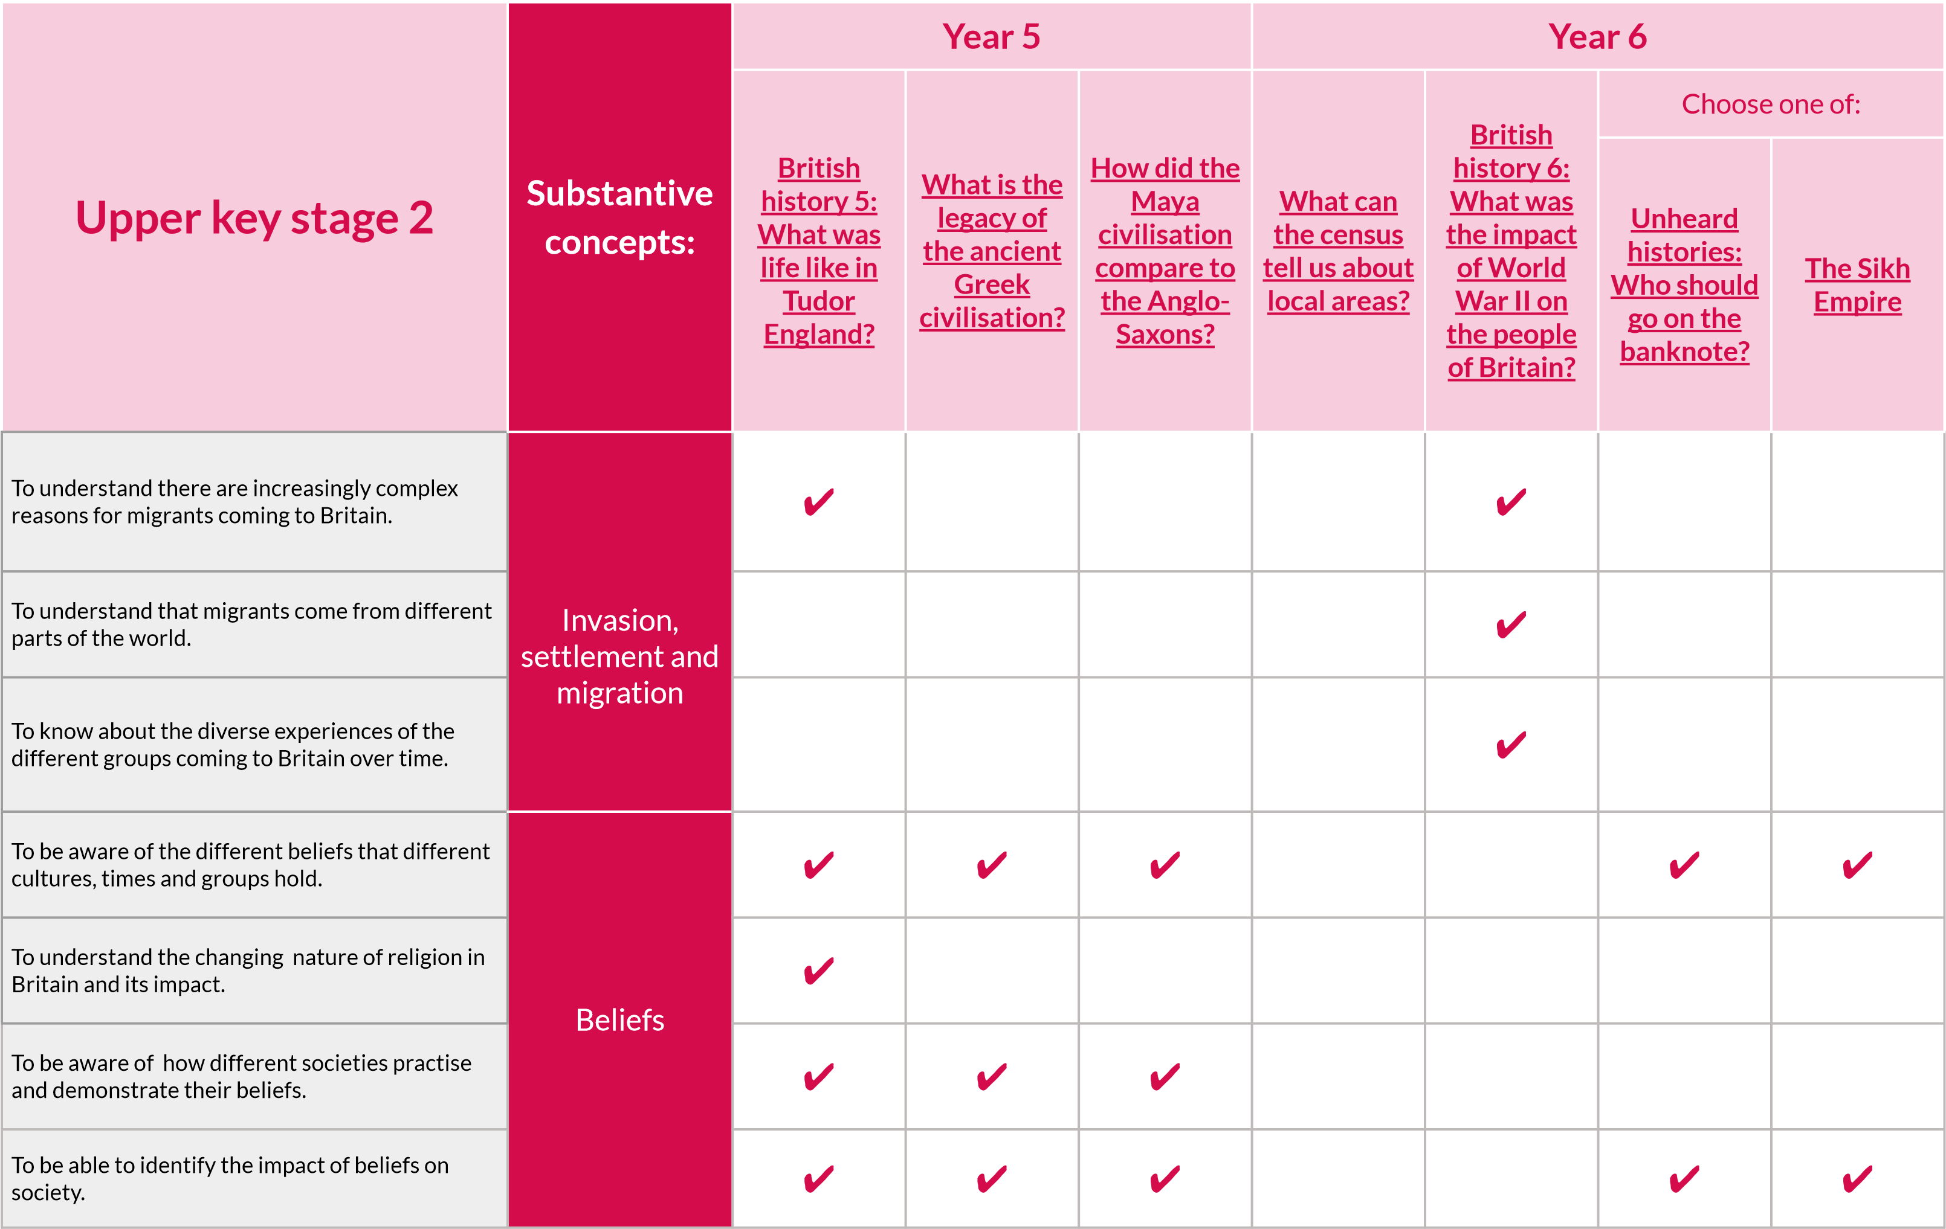

|  |  |  |  |  |  |  |  |  |
| --- | --- | --- | --- | --- | --- | --- | --- | --- |
| **Upper key stage 2** | **Substantive concepts:** | **Year 5** | | |  | **Year 6** | | |
| **British history**  **5: What was life like in**  **Tudor**  **England?** | **What is the legacy of**  **the ancient**  **Greek**  **civilisation?** | **How did the**  **Maya**  **civilisation**  **compare to the AngloSaxons?** | **What can the census**  **tell us about local areas?** | **British history 6:**  **What was the impact of World**  **War II on the people of Britain?** | Choose one of: | |
| **Unheard**  **histories:**  **Who should go on the banknote?** | **The Sikh Empire** |
| To understand the changes and reasons for the organisation of society in Britain. | Civilisation  (social and cultural) | ✔ |  |  | ✔ | ✔ | ✔ |  |
| To understand how society is organised in different cultures, times and groups. | ✔ | ✔ | ✔ |  | ✔ | ✔ |  |
| To be able to compare development and role of education in societies. |  | ✔ |  | ✔ |  | ✔ |  |
| To be able to compare education in different cultures, times and groups. |  | ✔ |  |  |  |  |  |
| To understand the changing role of women and men in Britain. |  |  |  | ✔ | ✔ | ✔ |  |
| To understand that there are differences between early and later civilisations. |  | ✔ | ✔ |  | ✔ |  |  |

**Key skills and knowledge by unit**

**Upper key stage 2**

**Substantive**

**concepts:**

**Year 5**

**Year 6**

**British**

**history 5:**

**What was**

**life like in**

**Tudor**

**England?**

**What is the**

**legacy of**

**the ancient**

**Greek**

**civilisation?**

**How did the**

**Maya**

**civilisation**

**compare to**

**the Anglo-**

**Saxons?**

**What can**

**the census**

**tell us about**

**local areas?**

**British**

**history 6:**

**What was**

**the impact**

**of World**

**War II on**

**the people**

**of Britain?**

Choose one of:

**Unheard**

**histories:**

**Who should**

**go on the**

**banknote?**

**The Sikh**

**Empire**

To know that trade routes from Britain

expanded across the world .

Trade

✔

✔

To understand there was a race to discover new

countries and that this resulted in new items to

be traded in (e.g. silk, spices and precious metals.

✔

✔

✔

To understand that the expansion of trade

routes increased the variety of goods available.

✔

To understand that the methods of trading

developed from in person to boats, trains and

planes.

✔

To understand the development of global trade.

✔

✔

**Key skills and knowledge by unit**

|  |  |  |  |  |  |  |  |  |
| --- | --- | --- | --- | --- | --- | --- | --- | --- |
| **Upper key stage 2** | **Substantive concepts:** | **Year 5** | | |  | **Year 6** | | |
| **British history 5:**  **What was life like in**  **Tudor**  **England?** | **What is the legacy of**  **the ancient**  **Greek**  **civilisation?** | **How did the**  **Maya**  **civilisation**  **compare to the AngloSaxons?** | **What can the census**  **tell us about local areas?** | **British history 6:**  **What was the impact of World**  **War II on the people of Britain?** | Choose one of: | |
| **Unheard**  **histories:**  **Who should go on the banknote?** | **The Sikh Empire** |
| To understand that people in the past were as inventive and sophisticated in thinking as people today. | Achievements and follies of mankind | ✔ | ✔ |  |  | ✔ | ✔ |  |
| To know that new and sophisticated technologies were advanced which allowed cities to develop. |  | ✔ |  |  | ✔ |  |  |
| To understand the impact of war on local communities. |  |  | ✔ |  | ✔ |  |  |
| To know some of the impacts of war on daily lives. |  |  |  |  | ✔ |  |  |
| To be able to identify the achievements of civilisations and explain why these achievements were so important. |  | ✔ | ✔ |  |  | ✔ | ✔ |
| To be able to compare the achievements of different civilisations and groups. |  | ✔ | ✔ |  |  | ✔ | ✔ |

**Key skills and knowledge by unit**

This page shows recent updates to this document.

**Version history**

|  |  |
| --- | --- |
| **Date** | **Update** |
| 05.01.23 | Updated to reflect the re-organisation of the strands and the inclusion of a ‘Topic knowledge’ strand. This document now includes disciplinary knowledge under the ‘Disciplinary concepts’ strand and to include Chronological knowledge under the ‘Chronological awareness’ strand. |
| 26.04.23 | Updated to reflect the units published in April 2023 and the change to the Year 6 summer unit from ‘Migration’ to ‘Unheard histories’. |
| 10.05.23 | Update to skills listed on p.18. |
| 05.07.23 | Updated to correct an error on p.27 |
| 06.09.23 | Updated to include key skills and knowledge for newly published EYFS: Reception unit ‘Peek into the past’ (p.3-7). |
| 11.10.23 | Updated to include EYFS: Adventures through time unit and Y6 alternative unit ‘The Sikh Empire’. |
| 07.08.24 | Updated to remove duplicated statements. |
| 04.09.24 | Updated links. |
| 03.04.25 | Updated links and made changes to reflect refreshed units. |

**Progression of knowledge and skills**