Lawley Primary School

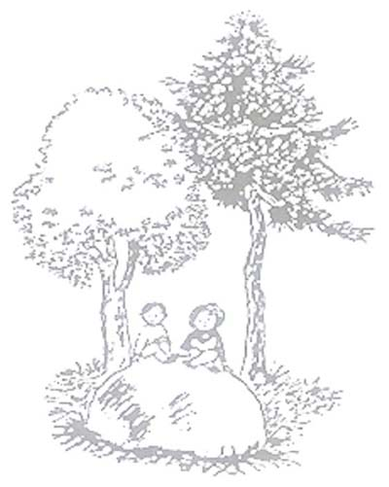

# **Geography Policy July 2025**

**Aims and Objectives**

Geography is the study of the world around us. The teaching and learning of Geography at Lawley Primary School is intended to equip pupils with the skills, knowledge and understanding to make sense of this constantly changing world.

* To encourage children to take an interest in, enjoy learning about and develop an understanding of the world in which they live.
* To stimulate the children’s sense of their own identity through learning about where they live and its relationships with other countries worldwide and to foster an awareness and understanding of our diverse world.
* To develop an understanding of physical and human processes and patterns.
* To develop the skills required to interpret maps, plans, photographs and other secondary sources needed to understand geographical ideas and concepts.
* To develop a knowledge and sense of place by investigating: the features and characters of a place; the similarities, differences and relationships between places and how people live in them.
* To encourage children to have pride in and take care of their local environment by making them aware of how they can play an important part in the sustainability of the world.
* To develop an awareness of global issues through critical thinking about global development.

### **Planning**

Geography will be taught at Lawley through the use of the school’s

medium-term plans based on the 2014 National Curriculum and closely following the School’s Geography progression grids to ensure that skills are built on and developed year on year.

### **In Early Years**

Geography is taught in Reception as an integral part of the topic work through child-initiated and adult led activities. Activities and opportunities are presented to children following the Understanding of the World Strand of the Development Matters document and on leaving Reception the aim is that children will be able to ‘Talk about the features of their own immediate environment and how environments might vary from one another’.

### **In Key Stage 1**

Pupils will develop knowledge about the world, the United Kingdom and their locality. They will understand basic subject-specific vocabulary relating to human and physical geography and begin to use geographical skills, including first-hand observation, to enhance their locational awareness.

**In Key Stage 2**

Pupils will extend their knowledge and understanding beyond the local area to include the United Kingdom and Europe, North and South America. This will include the location and characteristics of a range of the world’s most significant human and physical features. They will develop their use of geographical knowledge, understanding and skills to enhance their locational and place knowledge.

|  |
| --- |
| **Geographical Skills will be developed in a number of ways throughout school life including** -   * Children being given a wide range of experiences and resources. * Children being encouraged to ask and answer questions, select and record information for evaluation and assessment. * Teachers in all classes exploring and planning appropriate opportunities for using ICT to enhance children’s learning experiences in Geography. * Being asked questions and asking to observe, record, express opinions, analyse evidence, draw conclusions, collect and record evidence. * By being taught to use correct vocabulary, develop fieldwork skills, use secondary sources, use globes and maps at a range of scales. * By Undertaking fieldwork using a variety of skills, instruments and techniques. * By Making using and interpreting maps and plans at a variety of scales. * By building up a location framework of the size and position of places from the use of aerial photographs, plans, atlases and globes. * By using ICT as an informative source as well as to handle, sort and present information. * By investigating real people’s lives through meetings, case studies, videos, text and photographs. * By undertaking studies of places and themes in both local and worldwide localities. * By visiting a variety of places to enjoy first-hand experiences of what those places are like. * By using secondary sources to learn about places they cannot visit. * By discussing their own experiences of places or topical events e.g. holidays, sport, news. * By collecting sorting and presenting data in diagrams and maps in order to recognise patterns and relationship within and between places. * By Investigating physical and human processes through first-hand experiences or written resources, with increased independence. * By undertaking local and worldwide studies focusing on the environmental, social and political issues that influence the character of the places. * By exploring the significance of people’s beliefs, values and attitudes about the world. * By Investigating the need for sustainability within an environment or community. * By investigating familiar places to which they belong. * By considering the ways we are connected and linked to other places and people worldwide. * By engaging in learning activities that promote positive values and attitudes towards people throughout the world. * By developing feelings for the qualities of both natural and human-influence landscapes through visits and visual materials. |

**Recording and Assessment**

We assess by observing and questioning the children, evaluating knowledge at the start and end of a taught unit and carrying out a scrutiny of work and discussions with children across the school for progression and to identify the areas for improvement.

Progress and achievement in Geography is reported to parents and carers each year in the annual report.

**Role of the Geography Subject Leader**

* to develop the geography policy throughout the school
* to monitor progress in geography
* to keep up to date with development in geography education
* to offer support and advice to colleagues

Written by:

Lisa Burton

July 2025

This Policy was approved by the Headteacher on

Signed ………………………………….(Head)

Review Date: