A Note from the teachers
Welcome back! We hope everyone had a good Easter break and not eaten too much chocolate!
This term will be one filled with exciting learning and experiences. If you need to contact us please email:
abi.bennion@taw.org.uk
caitlin.folger@taw.org.uk
Important Reminders

PE lessons continue to be taught on Tuesday mornings (outside) and Wednesday afternoons (inside). Due to Health and Safety, we are unable to allow children to take part in PE lessons without a PE kit.
Please ensure water bottles are brought into school DAILY.
As the Summer months are coming, if it is a hot, sunny day please apply sunscreen to your child BEFORE school and provide a sunhat and sunglasses.

Lawley Primary School
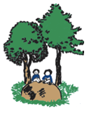

Year 1
Newsletter

Reading/Phonics:

The reading challenge is back, and we expect at least 3 entries in your reading diaries a week.

You can also practise applying your phonics knowledge and handwriting when completing your spellings and sentences.
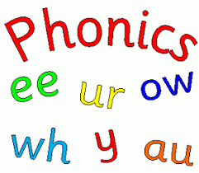
This term in class:

Our Topic is ‘Pack Your Bags!’ We will be learning all about animals and their habitats and modes of transport.

In Maths we will be looking at doubling and halving, as well as continuing with adding and subtracting, number bonds, etc.

In Science we will be looking at animals and their habitats.

In English we will continue to rehearse our phonics, punctuation and storytelling.


Educational Visits and Visitors

We are hoping to have an exciting adventure to Statfold transport museum and a Hindu Temple in Summer 2.
Homework
Spellings will be sent home on a Friday to be tested on the following Friday.

Maths’s homework this term will be a mix of skip counting and number bond facts.

Our expectation is that your child reads for at least 10 minutes every day.

Due to the upcoming Phonics Screening, we would love for you to be doing some extra phonics daily with your children.

