A Note from the teachers
Welcome back! We hope everyone had a good Christmas break.
This term will be another filled with exciting learning and experiences. If you need to contact us please email:
abi.bennion@taw.org.uk
caitlin.folger@taw.org.uk
Important Reminders
PE lessons continue to be taught on Tuesday mornings (outside) and Wednesday afternoons (inside). Please continue to send your child in P.E kit on these days.

Please ensure labelled water bottles are brought into school DAILY. Fruit is supplied daily for the children but if you would like to send a snack in our policy is fruit or veg Monday – Thursday and a healthy snack on a Friday.

All clothing also needs to be labelled as if items are lost and not labelled it can be very difficult to locate and get back to you.

Please discourage children from bringing any items from home in as this causes great upset when the items get lost or broken.
Lawley Primary School

Year 1
Newsletter
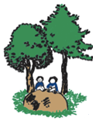

This term in class:
Our Topic is Where on Earth? We will be looking at different explorers and the countries they have found. We are concentrating on the Polar regions this half term and animals in our local area next half term. We are also becoming explorers ourselves and visiting some different countries!
In Maths we will be looking at doubling and halving, as well as continuing with adding and subtracting, number bonds, etc.
In Science we will be looking at habitats of animals, plants and mini-beasts.
In English we will be looking at non-fiction texts all about habitats and animals, and also writing animal stories.
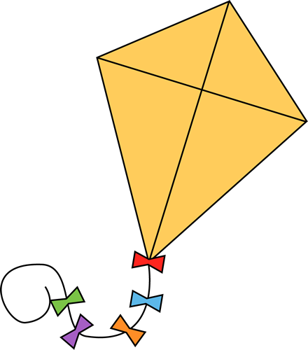
READING CHALLENGE

As always, we ask that you read with your child for at least ten minutes on a daily basis, and any reading is recorded in your child’s reading diary. We will be checking reading diaries on a Friday. However, reading diaries must be brought into school EVERY DAY. If there are three or more reading entries recorded, your child will move up a step on our class reading ladder. If by half term, they have reached the top of the kite, they will win a prize!


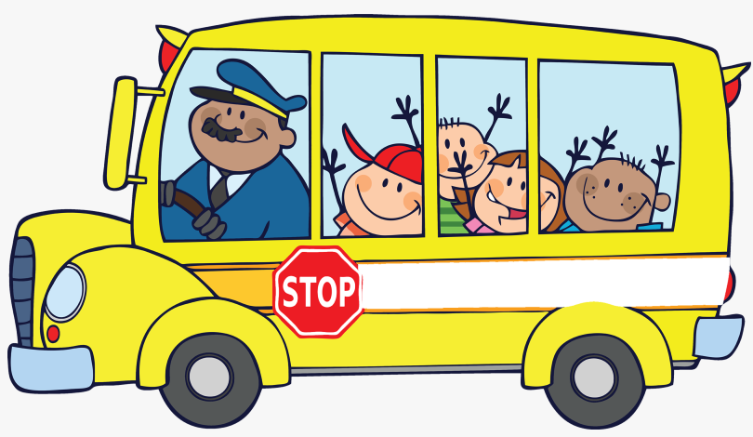

Homework

Spellings will be sent home on a Friday to be tested on the following Friday.

Maths homework will continue to go out weekly. This half term we will work on counting in 5’s.

Our expectation is that your child reads at least 3 times a week.
Trips and Visitors:

During this term we are arranging a couple of visitors into school including an explorer and a visit from Shropshire Falconry.

