SEND Newsletter Summer 2023
Mrs Olenik-Pritchard
Coffee morning:
This term, our coffee morning focused on the ELSA support we provide in school and transition.
A big thank you to Mrs Robinson who came and presented and to those that attended. It was lovely to see you and talk about how we support your child’s emotional literacy in school and their move to their next class. If you were unable to make our morning but are interested in the presentation, a copy of the PowerPoint was published on our Facebook page.  
Lawley Primary School

HERE COMES THE SUMMER!

We hope you’ve all had a wonderful summer term and are now looking forward to the 6-week break.

For some parents, carers, and families of children with Special Educational Needs, you might be feeling a little different about the time out of school. The break in routine, the additional expense, the worry about getting back into a new school year can all take the shine off the coming sunny days. For others, this is a welcome opportunity to spend time together and relax. However you might feel, I hope you find some useful information in this newsletter to support you.

In this edition of our SEN newsletter, I’m going to share some information about the 3 senses you might not be as familiar with but can be involved in ‘sensory overload’ – something some children might experience over the holiday, plus ways that might help.


Vestibular

Vestibular is all about motion – spinning, swinging, balancing, tipping etc. Do they like to spin in a circle or on a swing? Do they tip their chair or stool? Do they not sit straight? These are all ways for someone to self-regulate and are really comforting for some people. It can help people feel safe, calm, balanced. So, giving plenty of opportunities to indulge in these sensations safely might support them to be calmer and happier. If things seem to be getting stressful during the holiday, suggest an activity that will indulge this sense. It may help.
Don’t forget our firm favourite ‘Cosmic Kids Yoga’.

Please also find attached to the email, a leaflet from Telford and Wrekin, SENDIASS, advertising a ‘Talking SEND’ Summer family session where you can go along and meet the SENDIASS team.

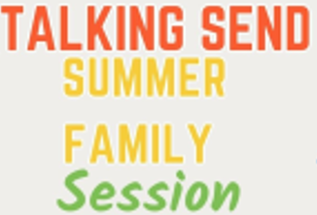

For more information about local SEND news, please visit the Local Offer page:
https://www.telfordsend.org.uk/homepage/14/send_news

We wish you a very happy break and look forward to welcoming you back in the Autumn term.


Interoception

Interoception is all about feelings – what is happy? What is sad? What is hunger? What is thirst? Sometimes, people with a neurodiversity don’t recognise their feelings. These can be emotional or physical. You might find it useful to prompt them to drink or snack, or to work with emotion picture cards to support their communication over the 6 weeks.

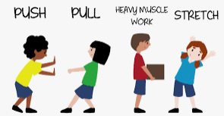
Proprioception

Proprioception is all about grounding. Some people require ‘heavy work’ to help them calm and regulate their mood, particularly people diagnosed with ADHD. Jobs like carrying, pushing, lifting, pulling etc can be helpful to support mood regulation, doing some gardening would be perfect to support this! Bouncing is also good. Any physical activity will help support a more positive mood.
Important Information:
School Support Maps
Your child’s teacher will be sending home the reviewed summer support plan for you to look at over the holiday. By the end of the third week back, you should have received contact from your child’s new teacher to discuss the review and explore the new plan for the Autumn term.

