SEND Newsletter Spring 2023
Sensory Room:
At Lawley, we continue to add equipment and resources to our sensory room, an area that can be accessed when children require time for sensory support or a moment to break away from their classroom and regulate themselves. This term, children have loved the light mirror, the tactile books, and the bead mats.
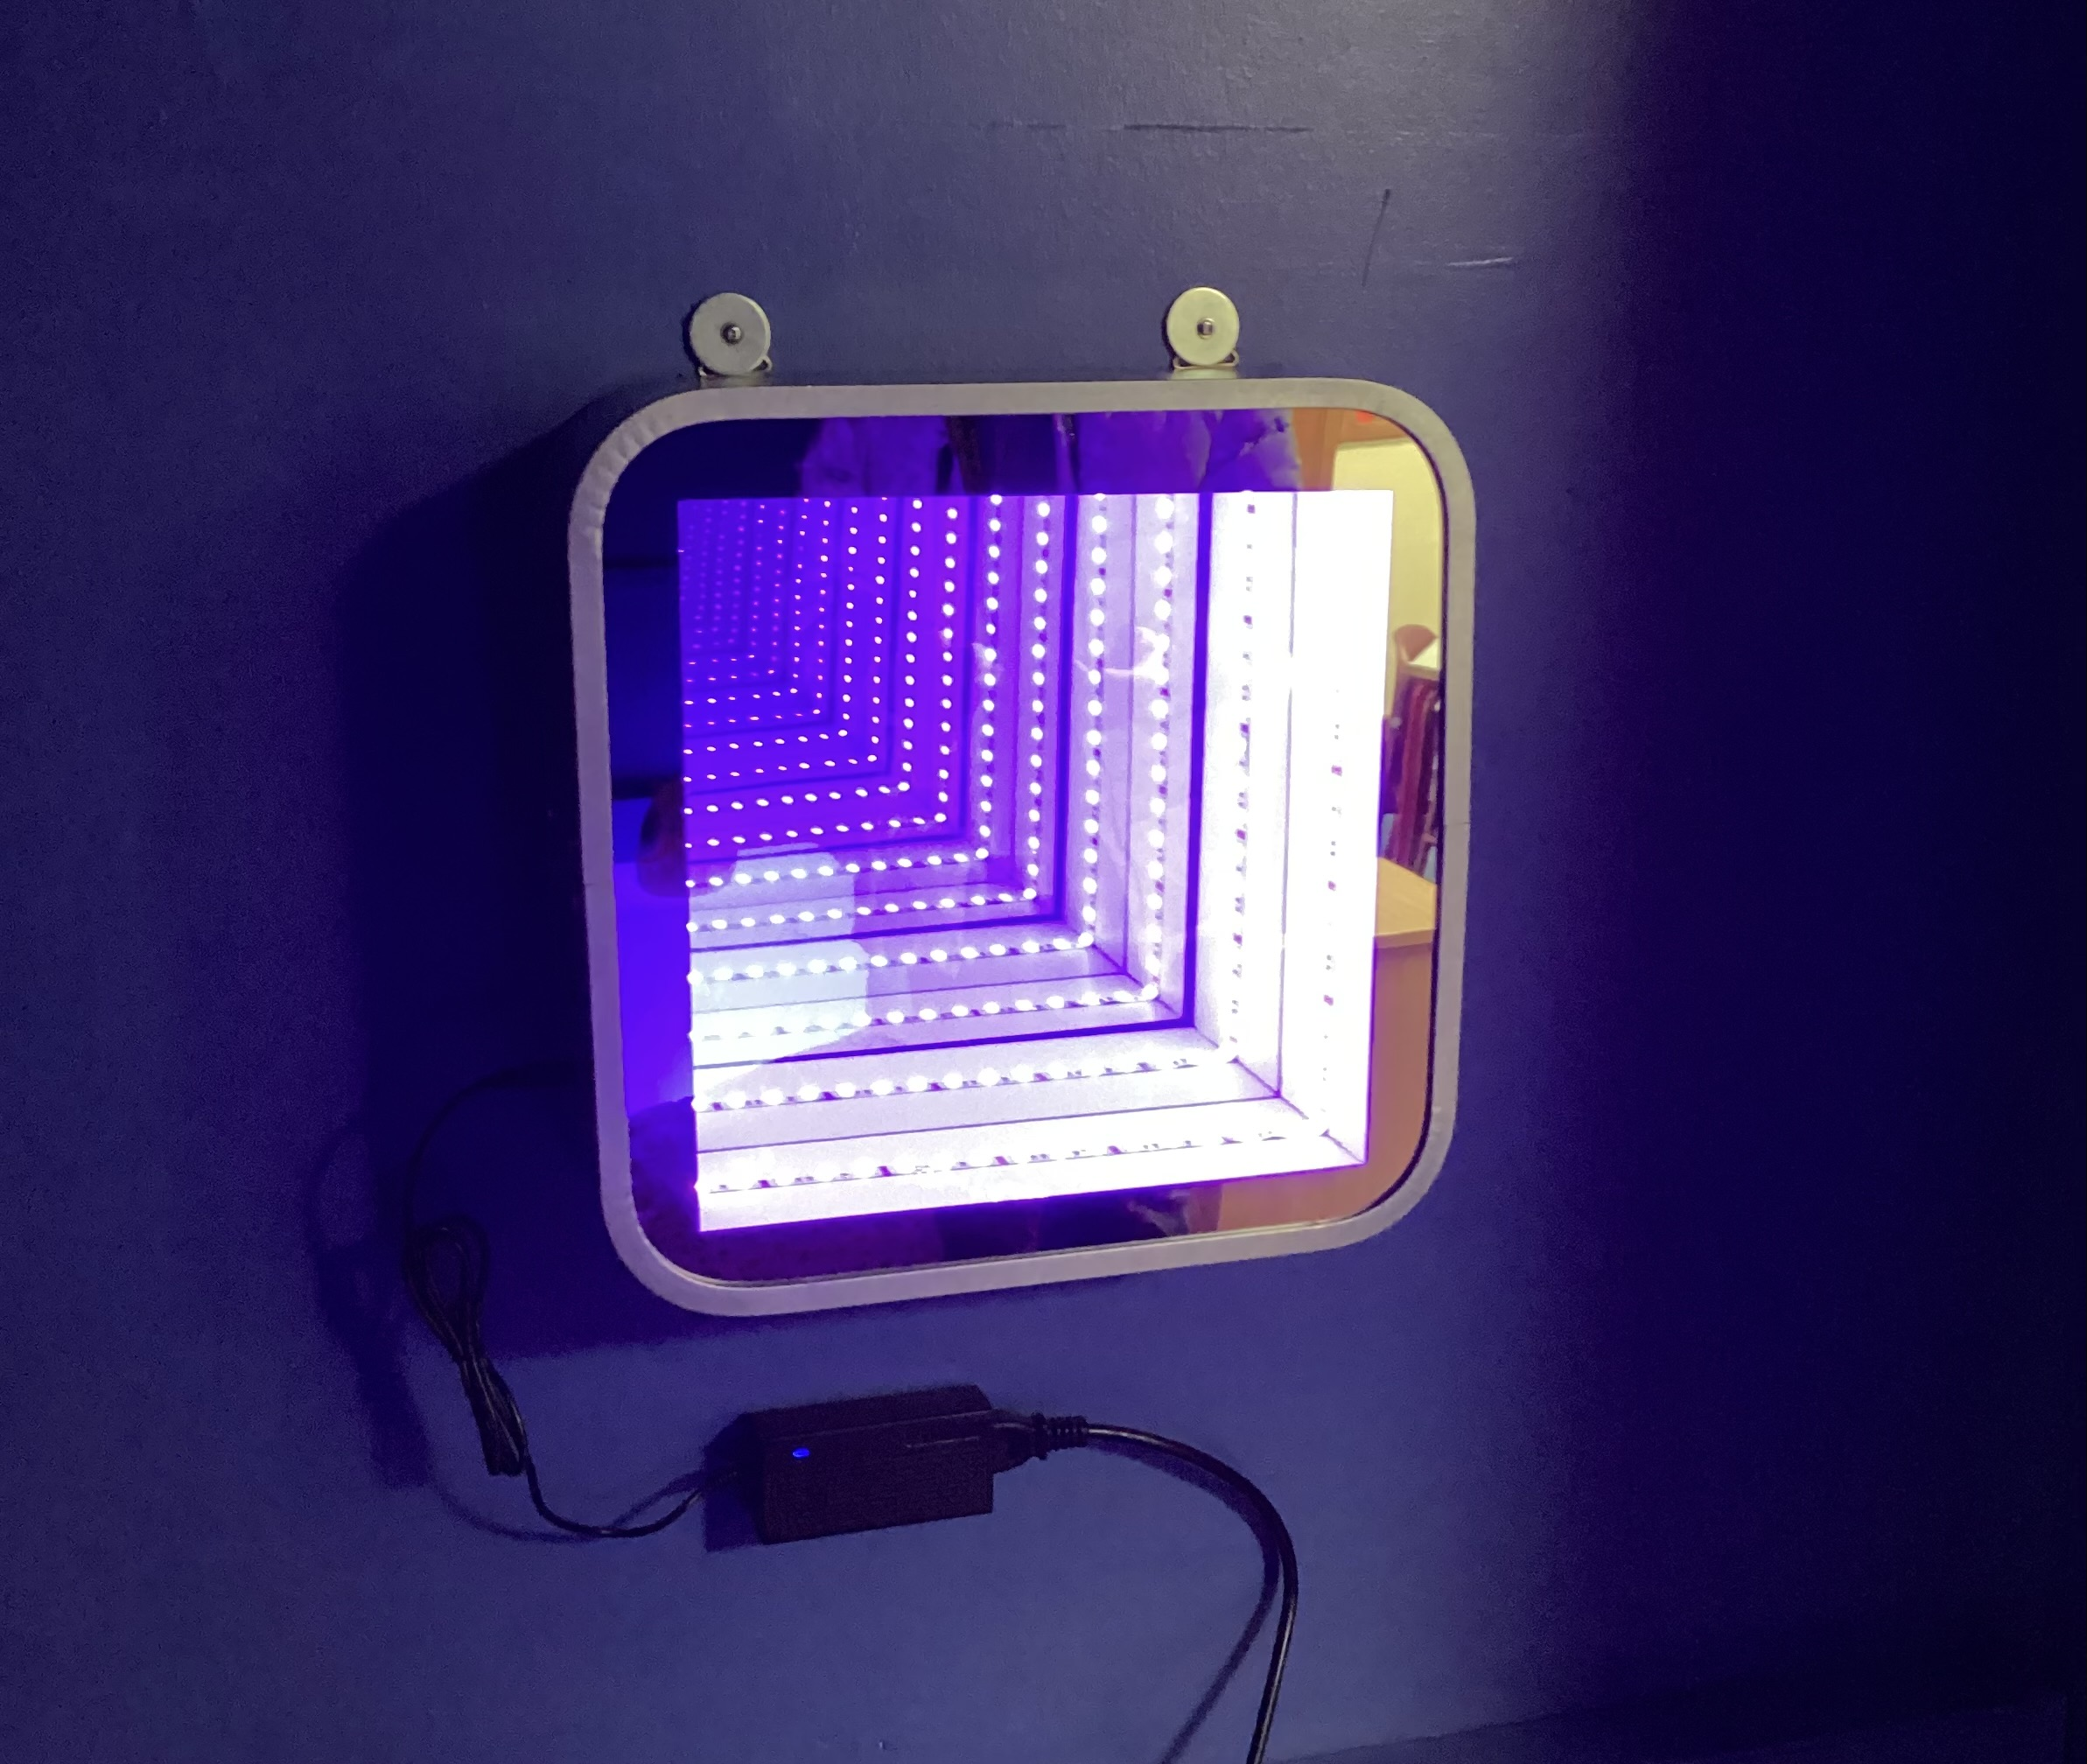

Lawley Primary School

We hope you’ve all had a wonderful Spring term.
This term has seen us recognise two important Awareness Days.

On Tuesday 21st March, we celebrated individual differences amongst our school and community as we recognised ‘World Down Syndrome Day’. Children came to school rocking their odd socks and spoke about the reason behind their odd sock choices in assembly and class.
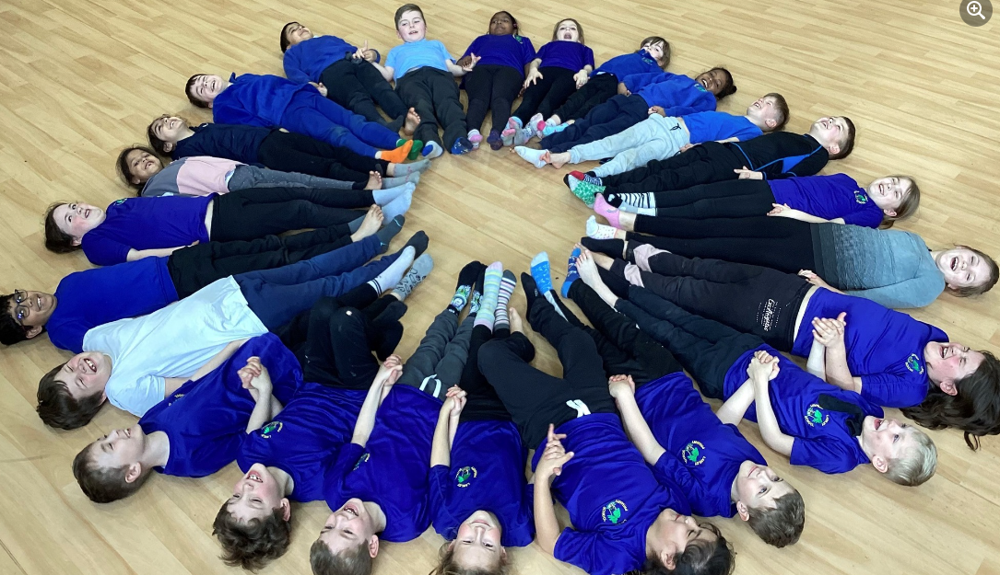

During the week commencing 27th March, we recognised ‘Autism Acceptance Week’. With approximately 1 in 100 people being diagnosed with autism, we wanted to share important information with our children about the condition that can change the way people see and understand the world around them. Autism Acceptance Week was about celebrating our similarities and differences, and that it is OK that we are all different from one another.
In the KS1 assembly, we used a Sesame Street clip to introduce autism to the children and in classes they watched the clip ‘Meet Julia’, an autistic character in the series. In the KS2 assembly, we focussed on some well-known autistic individuals to demonstrate to the children that autism is not something that will ever hold you back, in fact, Tom Stoltman has proven that it can help you be the Strongest person in the World!


Easter holiday:
This Easter, Telford and Wrekin are promoting their ’10 by 10, with a focus on SEND’. They are committed to ensuring that children with SEND can fully participate in 10 by 10 and there are a diverse range of activities accessible to all primary school children in the borough. Four spotlight activities accessible for children and young people with SEND in Telford and Wrekin include swimming, ice-skating, events running at The Special Needs Activity Centre (SNAC) Telford and Silhouette Dance Club. For more information, please follow the link below and have a wonderful Easter.
https://content.govdelivery.com/accounts/UKTW/bulletins/350034e

Autism Acceptance Week
As well as information presented in assembly and classes, we wanted to mark this week by coming together and doing something as a whole school. As ASD is a social disorder and is often accompanied by speech and language difficulties, we thought it would be great to have fun blowing bubbles outside. Bubbles are often used to support developing attention skills, impulse control, and language. They create a great shared experience and are lots of fun. Be sure to look out for us in the Shropshire Star!

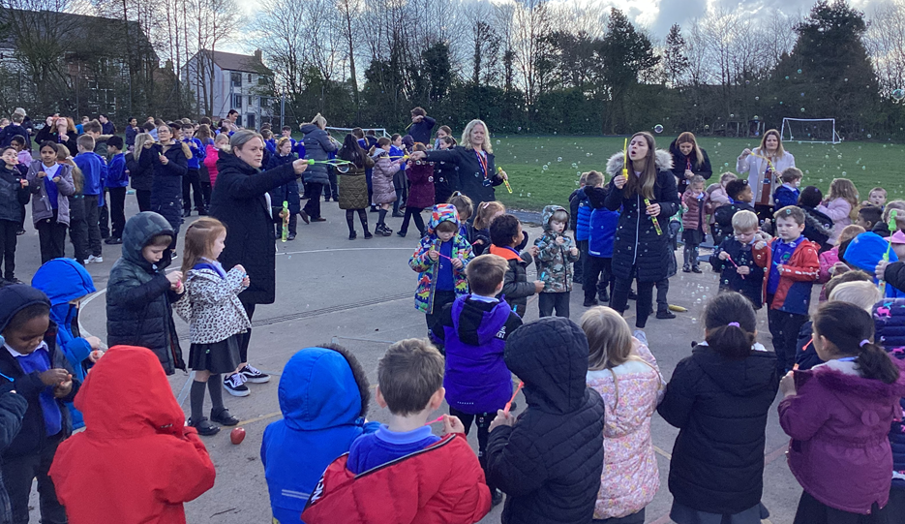

Coffee morning:
This term, our coffee morning also spread understanding around autism and following suggestions from our last get together, Mrs Nicholls was invited to share a range of activities that could be used at home to develop speech and language.
Thank you to all those that could attend, we look forward to the next.

Important Information:
School Support Maps
Your child’s teacher will be writing new support maps for the Summer term. You will be contacted by the end of the first week back to arrange a time to come and discuss these new interventions.

