Welcome to our first SEND Newsletter and what a term it has been! Autumn 2022
Sensory Room:
Over the Summer, we worked hard to create a space in our school where children with sensory needs or social and emotional needs can go to relax, destress and diffuse anxieties, through exploring fidgets, textures, visuals and sounds.

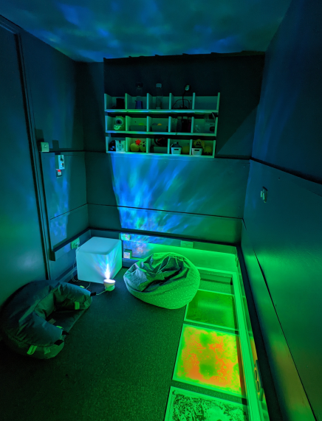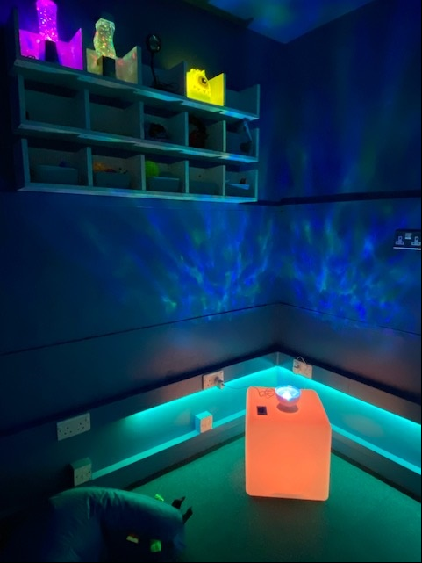

Lawley Primary School

Introductions: New to role
SENDCo

Mrs Olenik-Pritchard
“Having a daughter on the autistic spectrum and a son currently going through the assessment process, I’m passionate about ensuring that children with additional needs at Lawley Primary School are supported effectively and that families feel involved, informed and listened to throughout their child’s journey with us. This term has already seen changes to the way in which we provide provision and support at Lawley and I look forward to what’s to come.”

Inclusion Manager

Miss Gray
“I am extremely proud to be Lawley’s Inclusion Manager as I have been interested in the provision in school for pupils with Special Needs throughout my teaching career and I am looking forward to making a difference to the pupil’s school lives.”

Parent SEND Governor

Kate Kneller
“Hello, I'm Kate and I'm the SEND Governor for Lawley Primary. My role is to support Mrs Olenik and the great team we have as they work everyday to meet the needs of our children, and then to be a link back to the Board of Governors so that we all have a good understanding of how everything is progressing and how we might be able to help in future. As a parent of children with special educational needs myself, I have seen first hand how critical and transformative the right support can be to a child's happiness and self-esteem when barriers to learning are reduced, and I want to help make that happen for all our children at Lawley.





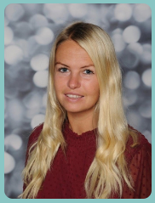
Christmas holiday:
We hope you all have a wonderful Christmas break. For some children, Christmas can be difficult to navigate. There can be many changes to routines, more social occasions, sensory triggers and additional demands on behaviour so be kind to yourselves. Don’t panic if Christmas dinner for your child consists of pizza and chips and adapt the festivities to suit your family not others.
Have a wonderful holiday together and we wish you a very happy new year.

Important Information:
School Support Maps
At the end of this term, your child’s class teacher will be sending home a reviewed Autumn term support map so you can see your child’s progress towards their Autumn term targets.
They shall then make contact to arrange a meeting with you at the beginning of next term (before 13.1.23).
During this meeting, you shall be invited to come into school (or on Teams should you wish) to discuss your child’s progress and look at their new Spring targets.
Don’t forget you can see some of your child’s intervention work in their Showbie folders.

Educational Psychologist
This term, we welcomed our new Educational Psychologist into school, Dr Dan Cumber. He works for Telford and Wrekin Education Authority and will be working alongside us to support our pupils in school.
Coffee morning:

This term, we hosted our first SEND coffee morning.
It was wonderful to welcome parents into school and begin to share experiences and get to know everyone.

We shall have another coffee morning next term so we can continue to share advice and experiences. During this time, we shall also have a specific focus on some speech and language support that can be implemented at home. This will be delivered by Mrs Nicholls
who supports our SALT work in school.
SEND Review:
This term, we welcomed Emma Heeley, a local Headteacher and SENDCo into school to conduct a SEND review. During her day, she observed lessons and interventions, spoke to children, staff, parents and Kate Kneller and provided a report of her findings. Throughout her time with us, we were very proud of our children and we look forward to sharing points from the review with you when it is finalised.
Good luck:
Finally, we wish Miss Gray lots of luck as she leaves for her maternity at the end of term and look forward to meeting her new baby!

